**NGO::CONNECT Portal**

A networking portal to connect corporates, social partners

and volunteers across the country

*A report submitted to Cluster Innovation Centre   
 in partial fulfilment of the requirements for the paper*

**VII.3 Software Project Management  
(Semester VII)**



***Submitted By***

Anushtha Kalia (11506)

Arjun Sharma (11507)

Lakshay Juneja (11516)

Nikhil Maheshwari (11518)

Raghav Singh (11522)

***Under supervision of***

Mr. Sachin Kumar

Mr. Anjani Kumar

# 

# Certificate

This is to certify that the work embodied in this report entitled NGO::CONNECT has been submitted to the Cluster Innovation Centre, the University of Delhi towards the fulfilment of paper VII.3, “Software Project Management”. This report has not been submitted in part or in full to any other University/ Institution.

The work has been carried out under the* supervision of Mr Sachin Kumar, Cluster Innovation Centre, University of Delhi.

Date: 12th November 2018

**Signature of Project Guide**

-------------------------

Prof. Sachin Kumar

-------------------------

Prof. Anjani Kumar

# 

# 

# Acknowledgement

We would like to acknowledge with thanks and appreciate all the people who played a role in the successful completion of this project.

Our sincere thanks go to our mentors, Mr Sachin Kumar & Mr Anjani Kumar, who guided us throughout the stages of this project. Finally, we would also like to thank Cluster Innovation Center for providing us with the facilities and the necessary resources to complete our work.

# List of Contents

**1 | Introduction** **7**

1.1 | Problem Statement 7

1.2 | Linear Sequential Model 8

1.3 | Team Structure 9

1.4 | Project Scheduling 10

1.4.1 | Degree of Rigor 10

1.4.2 | Computing the Task Set Selector table 10

1.4.3 | Timeline 11

**2 | Software Requirement Specification**12

2.1 | Introduction 12

2.1.1 | Purpose 12

2.1.2 | Scope 12

2.1.3 | References 12

2.1.4 | Overview 13

2.2 | General Description 13

2.2.1 | Product Perspective 13

2.2.2 | Product Functions 13

2.2.3 | User Characteristics 13

2.2.4 | General Constraints 13

2.2.5 | Assumptions and Dependencies 14

2.3 | Specific Requirements 15

2.3.1 | External Interface Requirements 15

2.3.1.1 | User Interfaces 15

2.3.1.2 | Hardware Interfaces 23

2.3.1.3 | Software Interfaces 23

2.3.1.4 | Communications Interfaces 23

2.3.2 | Functional Requirements 24

2.3.2.1 | Login form 24

2.3.2.2 | Registration Form 24

2.3.2.3 | Adding an internship as an NGO : 25

2.3.2.4 | Apply for an internship by a student 26

2.3.2.5 | Search engine 26

2.3.3 | Use Cases 27

2.3.3.1 | Use Case 1 27

2.3.3.2 | Use Case 2 28

2.3.3.3 | Use Case 3 29

2.3.3.4 | Use Case 4 30

2.3.4 | Non-Functional Requirements 28

2.3.4.1 | Performance 30

2.3.4.2 | Reliability 30

2.3.4.3 | Availability 30

2.3.4.4 | Security 30

2.3.4.5 | Maintainability 30

2.3.4.6 | Portability 30

2.3.5 | Inverse Requirements 30

2.3.6 | Design Constraints 30

2.3.7 | Logical Database Requirements 30

2.4 | Analysis Model 31

2.4.1 | Context Free Diagram 31

2.4.2 | Data Flow Diagram 32

2.4.3 | Architecture Diagram 33

2.4.4 | State Transition Diagram 34

2.4.5 | Structure Chart 35

**3 | Entity Relationship Diagram** **3**7

**4 | Data Dictionary** **3**8

**5 | Function Point metrics** **41**

**6 | Feasibility Study** **43**

**7 | Risk Analysis** **44**

**8 | Testing** **46**

8.1 | Signup feature 47

8.2 | Login feature 48

8.3 | Adding an Internship 49

8.4 | Search for an Internship 50

**9 |** **Memos 52**

**10 | References 54**

# 

# 

# 

# 

# List of Figures

Figure 01 | Linear sequential model 08

Figure 02 | Democratic team structure 09

Figure 03 | Landing page 14

Figure 04 | About us page 15

Figure 05 | Contact Us page 16

Figure 06 | Internships page 16

Figure 07 | Internship description 17

Figure 08 | Student login page 18

Figure 09 | Registration page 18

Figure 10 | Student Dashboard 19

Figure 11 | Student profile 20

Figure 12 | NGO Dashboard 20

Figure 13 | NGO Dashboard 21

Figure 14 | Add an internship form 21

Figure 15 | List of applicants for a particular internship 22

Figure 16 | Company Dashboard 23

Figure 17 | Context free Diagram for the project 31

Figure 18 | Data flow diagram for all three parties 32

Figure 19 | Architecture Diagram for the project 33

Figure 20 | State Transition Diagram for the Project 34

Figure 21 | Structure chart for student registration 35

Figure 22 | Structure chart for internship addition 35

Figure 23 | Structure chart for internship application 36

Figure 24 | ER diagram for the project 37

Figure 25 | Control flow graph for Signup feature 47

Figure 26 | Control flow graph for Login feature 48

Figure 27 | Control Flow Diagram for adding an internship 49

Figure 28 | Control flow diagram for searching an internship 51

# List of Tables

Table 01 | Task set selector table 10

Table 02 | Timeline 11

Table 03 | Use case 1 27

Table 04 | Use case 2 28

Table 05 | Use case 3 29

Table 06 | Use case 4 29

Table 07 | Data dictionary for company 38

Table 08 | Data dictionary for internship details 38

Table 09 | Data dictionary for NGO 39

Table 10 | Data dictionary for Student 39

Table 11 | Data dictionary for Student_internship_apply 40

Table 12 | Function point metric 42

Table 13 | Risk Analysis 45

Table 14 | Signup testing 47

Table 15 | Login testing 48

Table 16 | Adding an internship testing 50

Table 17 | Search for an internship testing 50

# 

# 

# 

# 

# 

# 

# 

# 

# 1 | Introduction

# 

## 1.1 | Problem Statement

We’ve seen frequently a number of young students willing to work for the social good, but cannot due to the lack of knowledge about the needs of the society. Or sometimes they are unable to find a use for their skills in uplifting the underprivileged. To tackle such situations and bring the student community and NGOs a little closer, we came up with the idea of NGO::CONNECT.

NGO::CONNECT is a platform where students can find meaningful internships with various Non-Governmental Organisations working to improve the living conditions of the underprivileged section of our society. The platform developed through this project is a culmination of these believes. We constantly work on finding new ways to drive the positivity of action. We are focused on building the future where students can experience real opportunities to give back to society while they continue their education and build a smarter future. We thrive to build a platform which helps the younger generation use their skills for making a better India.

## 1.2 | Linear Sequential Model

This portal created in this project was developed using Linear Sequential Model (also known as Waterfall Model or classic life cycle) because of the following reasons:

* As our system follow a systematic, sequential approach to software development that begins at the system level and progress through analysis, design, coding, testing and support.
* As the user is required in the initial stage of the system to help the team members to know about the requirements, nature of the program, information domain for the system, etc.
* All requirements for the system are well understood.
* As there is only one team to develop the system and to do all the tasks related to the system such as analysis, design, coding, testing.
* As this is a short duration project.

The linear sequential software process development model:

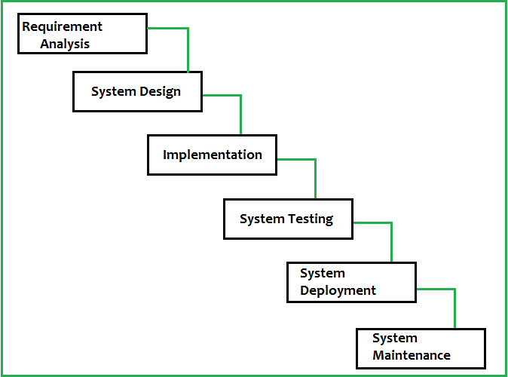

Figure 1: Linear sequential model[3]

## 1.3 | Team Structure

Team structure addresses the issue of the organization of the individual project teams. There are some possible ways in which the individual project teams can be organized. There are mainly three formal team structures: chief programmer, democratic, and the mixed team organizations although several other variations to these structures are possible. Problems of different complexities and sizes often require different team structures to achieve the solution.

**Team structure used:**

The **democratic team structure**, as the name implies, does not enforce any formal team hierarchy. Typically, a manager provides the administrative leadership. At different times, different members of the group provide technical leadership.

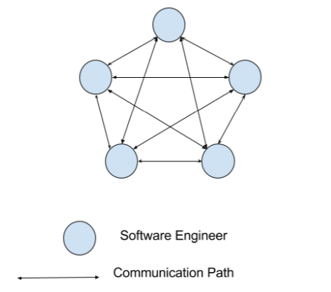

Figure 2: Democratic team structure[4]

**Reasons for working in a democratic team:**

* The democratic organization leads to higher morale and job satisfaction. It suffers from less man-power turnover.
* Democratic team structure is appropriate for less understood problems, since a group of engineers can invent better solutions than a single individual as in a chief programmer team.
* A democratic team structure is suitable for projects requiring less than five or six engineers and for research-oriented projects.For large sized projects, a pure democratic organization tends to become chaotic.
* The democratic team organization encourages egoless programming as programmers can share and review one another’s work.

## 

## 

## 1.4 | Project Scheduling

## 1.4.1 | Degree of Rigor

The degree of rigour with which the software process is applied may vary significantly.

The degree of rigour is a function of many project characteristics. Task sets are designed to

accommodate different types of projects and different degrees of rigour. Different tasks are:-

1. **The concept of development projects (Conc.)** that are initiated to explore some new business concept or application of some new technology.
2. **New application development projects (NDev.)** that are undertaken as a consequence of a specific customer request.
3. **Application enhancement projects (Enhan.)** that occur when existing software undergoes major modifications to function, performance, or interfaces that are observable by the end- user.
4. **Application maintenance projects (Maint.)** that correct, adapt or extend existing software in ways that may not be immediately obvious to the end-user.
5. **Reengineering projects (Reeng.)** that are undertaken with the intent of rebuilding an existing system in whole or in part.

## 1.4.2 | Computing the Task Set Selector table

|  |  |  |  |  |
| --- | --- | --- | --- | --- |
| **Adoption Criteria** | **Grade** | **Weight** | **Entry point multiplier (NDev.)** | **Product** |
| Size of project | 2 | 1.20 | 1 | 2.40 |
| Number of Users | 5 | 1.10 | 1 | 5.50 |
| Business criticality | 3 | 1.10 | 1 | 3.30 |
| Longevity | 1 | 0.90 | 1 | 0.90 |
| Stability of requirements | 3 | 1.20 | 1 | 3.60 |
| Ease of communication | 4 | 0.90 | 1 | 3.60 |
| Maturity of technology | 1 | 0.90 | 1 | 0.90 |
| Performance constraints | 3 | 0.80 | 1 | 2.40 |
| Embedded | 1 | 1.20 | 1 | 1.20 |
| Project staffing | 1 | 1.00 | 1 | 1.00 |
| Interoperability | 3 | 1.10 | 1 | 3.30 |
| Reengineering factors | 1 | 1.20 | 0 | 1.20 |
| **Task set selector(TSS)** |  |  |  | **29.30** |

Table 1: Task set selector table

**Product =** Grade x Weighting factor x Entry point multiplier (NDev.)

**Task set selector (TSS) =** [∑ (Product)] ፥ 12] = ***2.44166666667***

Also, we know that Task set selector value should be

**1.0<TSS<3.0**

**Structured.** The process framework activities will be applied for this project. Framework activities and related tasks appropriate to the project type will be applied and umbrella activities necessary to ensure high quality will be applied. SQA, SCM, documentation, and measurement tasks will be conducted in a streamlined manner.

## 1.4.3 | Timeline

|  |  |  |
| --- | --- | --- |
| **Start Date** | **Task** | **Duration** |
| 1/08/2018 | Requirement Gathering | 15 days |
| 15/08/2018 | Requirement Finalization | 10 days |
| 25/08/2018 | Design | 21 days |
| 15/09/2018 | Coding | 1 month |
| 15/10/2018 | Testing | 15 days |
| 1/11/2018 | Maintenance | 5 days |

Table 2: Timeline

# 

# 2 | Software Requirement Specification

## 

## 2.1 | Introduction

### 2.1.1 | Purpose

The purpose of the document is to collect and analyze all assorted ideas that have come up to define the system, its requirements with respect to consumers. Also, we shall predict and sort out how we hope this product will be used in order to gain a better understanding of the project, outline concepts that may be developed later, and document ideas that are being considered but may be discarded as the product develops.

India is the current youth capital of the world. 65 per cent of our population is below 35. There is a significant percentage which wants to contribute more and participate in social initiatives but they aren’t able to contribute time and efforts due to lack of a dedicated medium to connect them with these social initiatives and campaigns.

This portal will help connect individuals in finding ample opportunities with NGOs and various other (govt., semi-govt, etc.) social projects and campaigns across a scale of factors like type of work, location, period, whether can be done remotely, skills required, stipend, perks, etc.

Right now it is cumbersome and expensive for NGOs to assemble teams for social initiatives. This portal will help NGOs scout a diverse pool of talented volunteers and skilled people in different domains and diverse skill sets. This will help them in reducing recruiting and administration costs.

We plan on attracting youth by offering them attractive opportunities via our corporate sponsors. We will present corporates a detailed performance report of a certain number of NGOs, which will also include the potential of the project to be done, the workforce involved with it, financial and logistical requirements and estimates. This we think will ease the work of corporates as they will have a set of NGOs to choose from, according to their firm’s requirements.

### 2.1.2 | Scope

Primarily, the scope pertains to the E-Store product features for making Marvel Electronics and Home Entertainment project live. It focuses on the company, the stakeholders and applications, which allow for online sales, distribution and marketing of electronics. It also aims at specifying the requirements for the product to be built and caters to all these needs.

### 2.1.3 | References

Since our model is based upon bringing NGO’s and corporates together, so we took help from some of the major websites such as:

1. Internshala
2. Goonj

### 2.1.4 | Overview

NGO::CONNECT is a platform where students can find meaningful internships with various Non-Governmental Organisations working to improve the living conditions of the underprivileged section of our society. The aim of this model is to bring all the entities onto a single boat and we have done this by the help of an integrated platform which connects the students, NGOs and the corporates in such a manner such that the necessities of each individual is fulfilled.

## 2.2 | General Description

This section will give an overview of the whole system. It will also describe what type of stakeholders that will use the system and what functionality is available for each type. At last, the constraints and assumptions for the system will be presented.

### 2.2.1 | Product Perspective

The basic idea behind this software product is that usually, the internship websites mostly have listings of corporate internships which are even promoted higher up on every page, making it difficult for someone to come across an NGO internship. Hence, when an intern prospect visits such a website with a neutral perspective about interning at an NGO or a corporate, he/she is overwhelmed by the corporate internship listings. With the help of a portal dedicated to NGO internships filled with lucrative offers from investors/corporates, the number of people applying for NGO interns could increase drastically. Furthermore, it will also help companies to find NGOs that align with their interests to contribute and support as a part of their CSR responsibilities.

### 

### 2.2.2 | Product Functions

The product will allow the NGOs to list internships on the website. Registered students should be able to apply to listed internships NGOs can scan through their applications. Corporates shall also be able to register on the platform and scroll through the list of available NGOs and find their contact information. Furthermore, a search option shall be available which makes use of tags, keywords and locations.

### 2.2.3 | User Characteristics

A student is required to first register himself/herself by providing his/her personal and professional details. Then, the student can search and find the NGOs and positions he/she wants to intern at. An NGO also needs to register after which it can add internships and select amongst the applied interns. Corporates also need to register before they can make use of the portal to find relevant NGOs.

### 2.2.4 | General Constraints

Internships can be applied to only by the registered students. An NGO has to inform the admin after checking the list of applicants about the intern whom they want to select. A corporate has to contact the NGO via telephonic/email means and inform the admin panel, to begin with their linkage establishment.

### 2.2.5 | Assumptions and Dependencies

It is assumed that the students, NGOs and the corporates have systems with good internet connections to work upon. Also, since the admin panel will have to frequently access the backend directly, it should be familiar with the usage of the databases.

## 2.3 | Specific Requirements

### 2.3.1 | External Interface Requirements

#### 2.3.1.1 | User Interfaces

Our system has 3 different types of users, students, NGOs & corporates. Every student has their own page with specific information like their personal details, work profile, suggested and applied for internships. The main page of an NGO has their details listed, internship listings and the applications received for them. The landing page for a corporate account displays the NGOs they’re connected with. If a user is not a first-time user, he/she should be able to , while the first-time user will need to register first. Below various input screens are given.

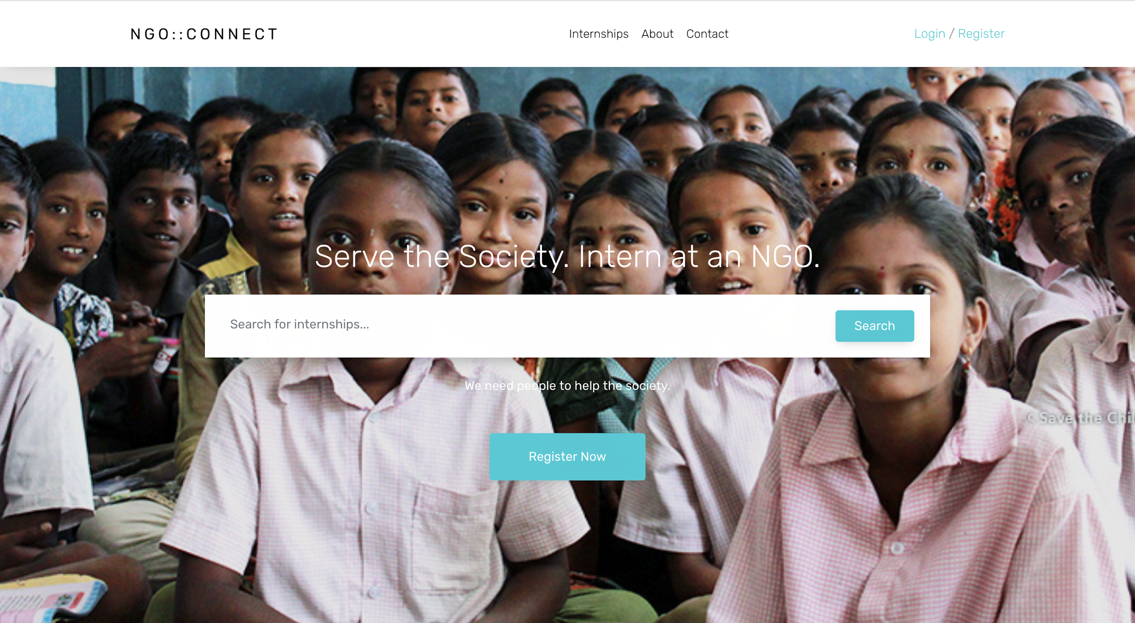

Figure 3: Landing page

|  |  |
| --- | --- |
| Parameter | Count |
| External Interface files | 0 |
| External Output | 0 |
| External Input | 0 |
| External Inquiry | 1 |

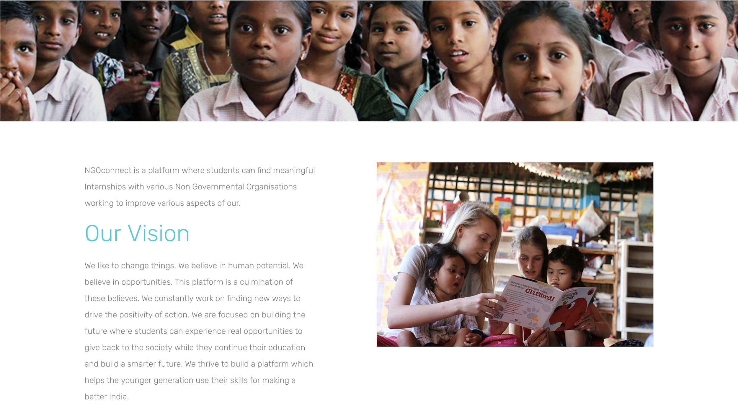

Figure 4: About us page

|  |  |
| --- | --- |
| Parameter | Count |
| External Interface files | 0 |
| External Output | 0 |
| External Input | 0 |
| External Inquiry | 1 |

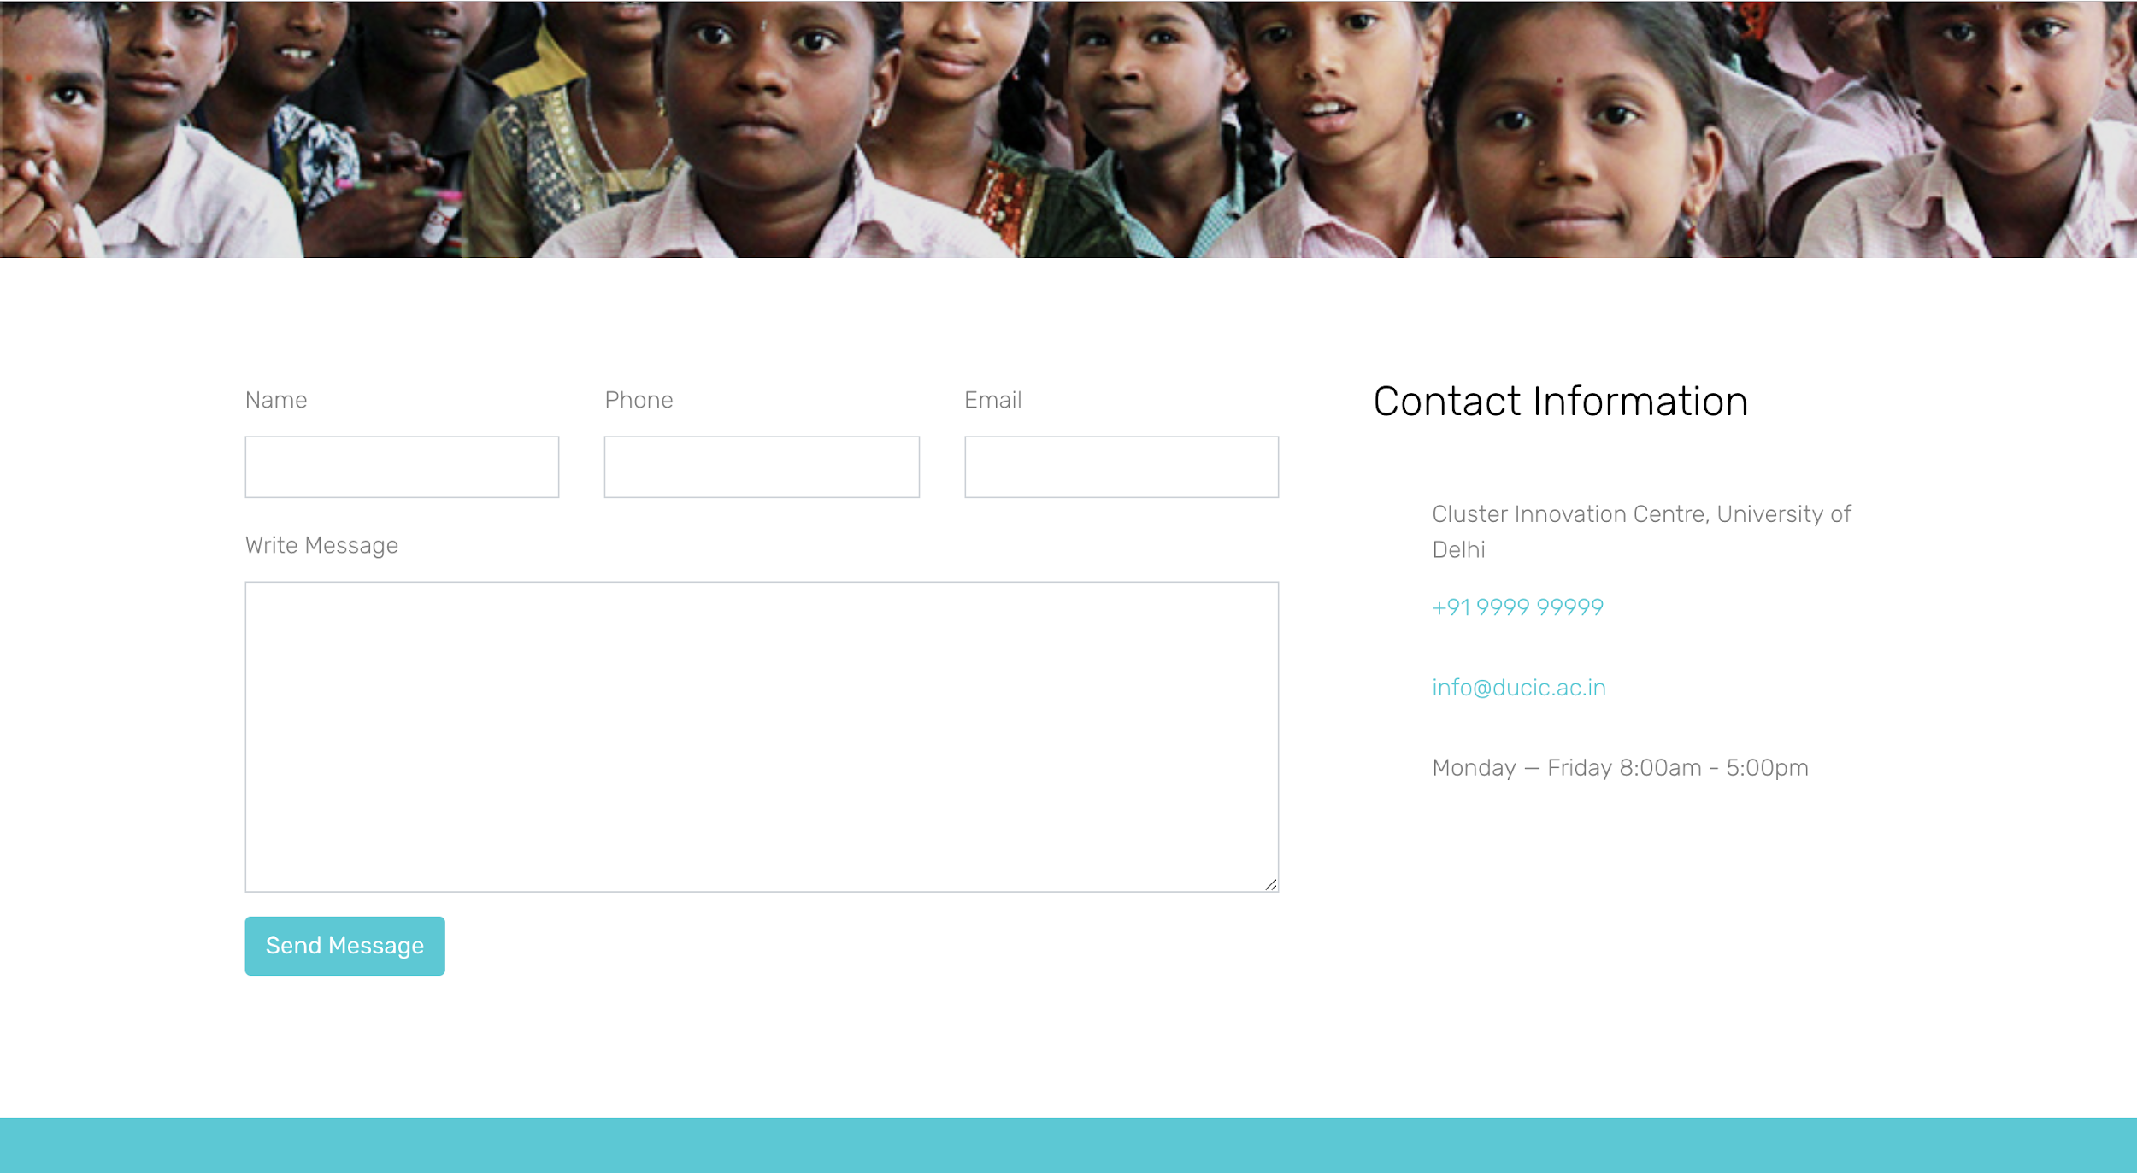

Figure 5: Contact Us page

|  |  |
| --- | --- |
| Parameter | Count |
| External Interface files | 0 |
| External Output | 0 |
| External Input | 0 |
| External Inquiry | 1 |

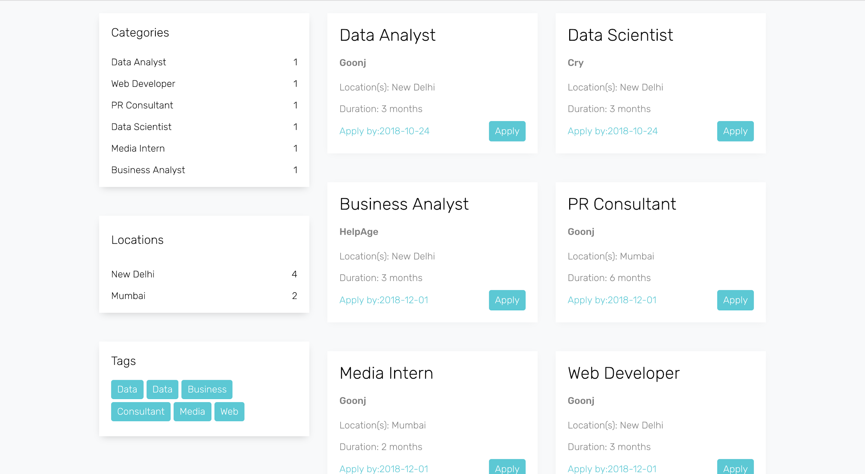

Figure 6: Internships page

|  |  |
| --- | --- |
| Parameter | Count |
| External Interface files | 0 |
| External Output | 0 |
| External Input | 0 |
| External Inquiry | 5 |

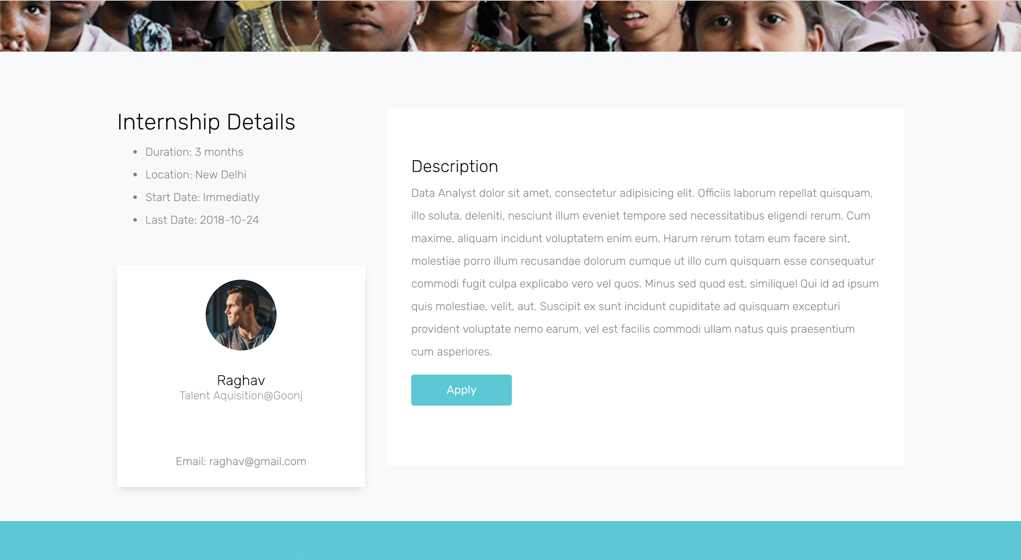

Figure 7: Internship description

|  |  |
| --- | --- |
| Parameter | Count |
| External Interface files | 0 |
| External Output | 0 |
| External Input | 1 |
| External Inquiry | 4 |

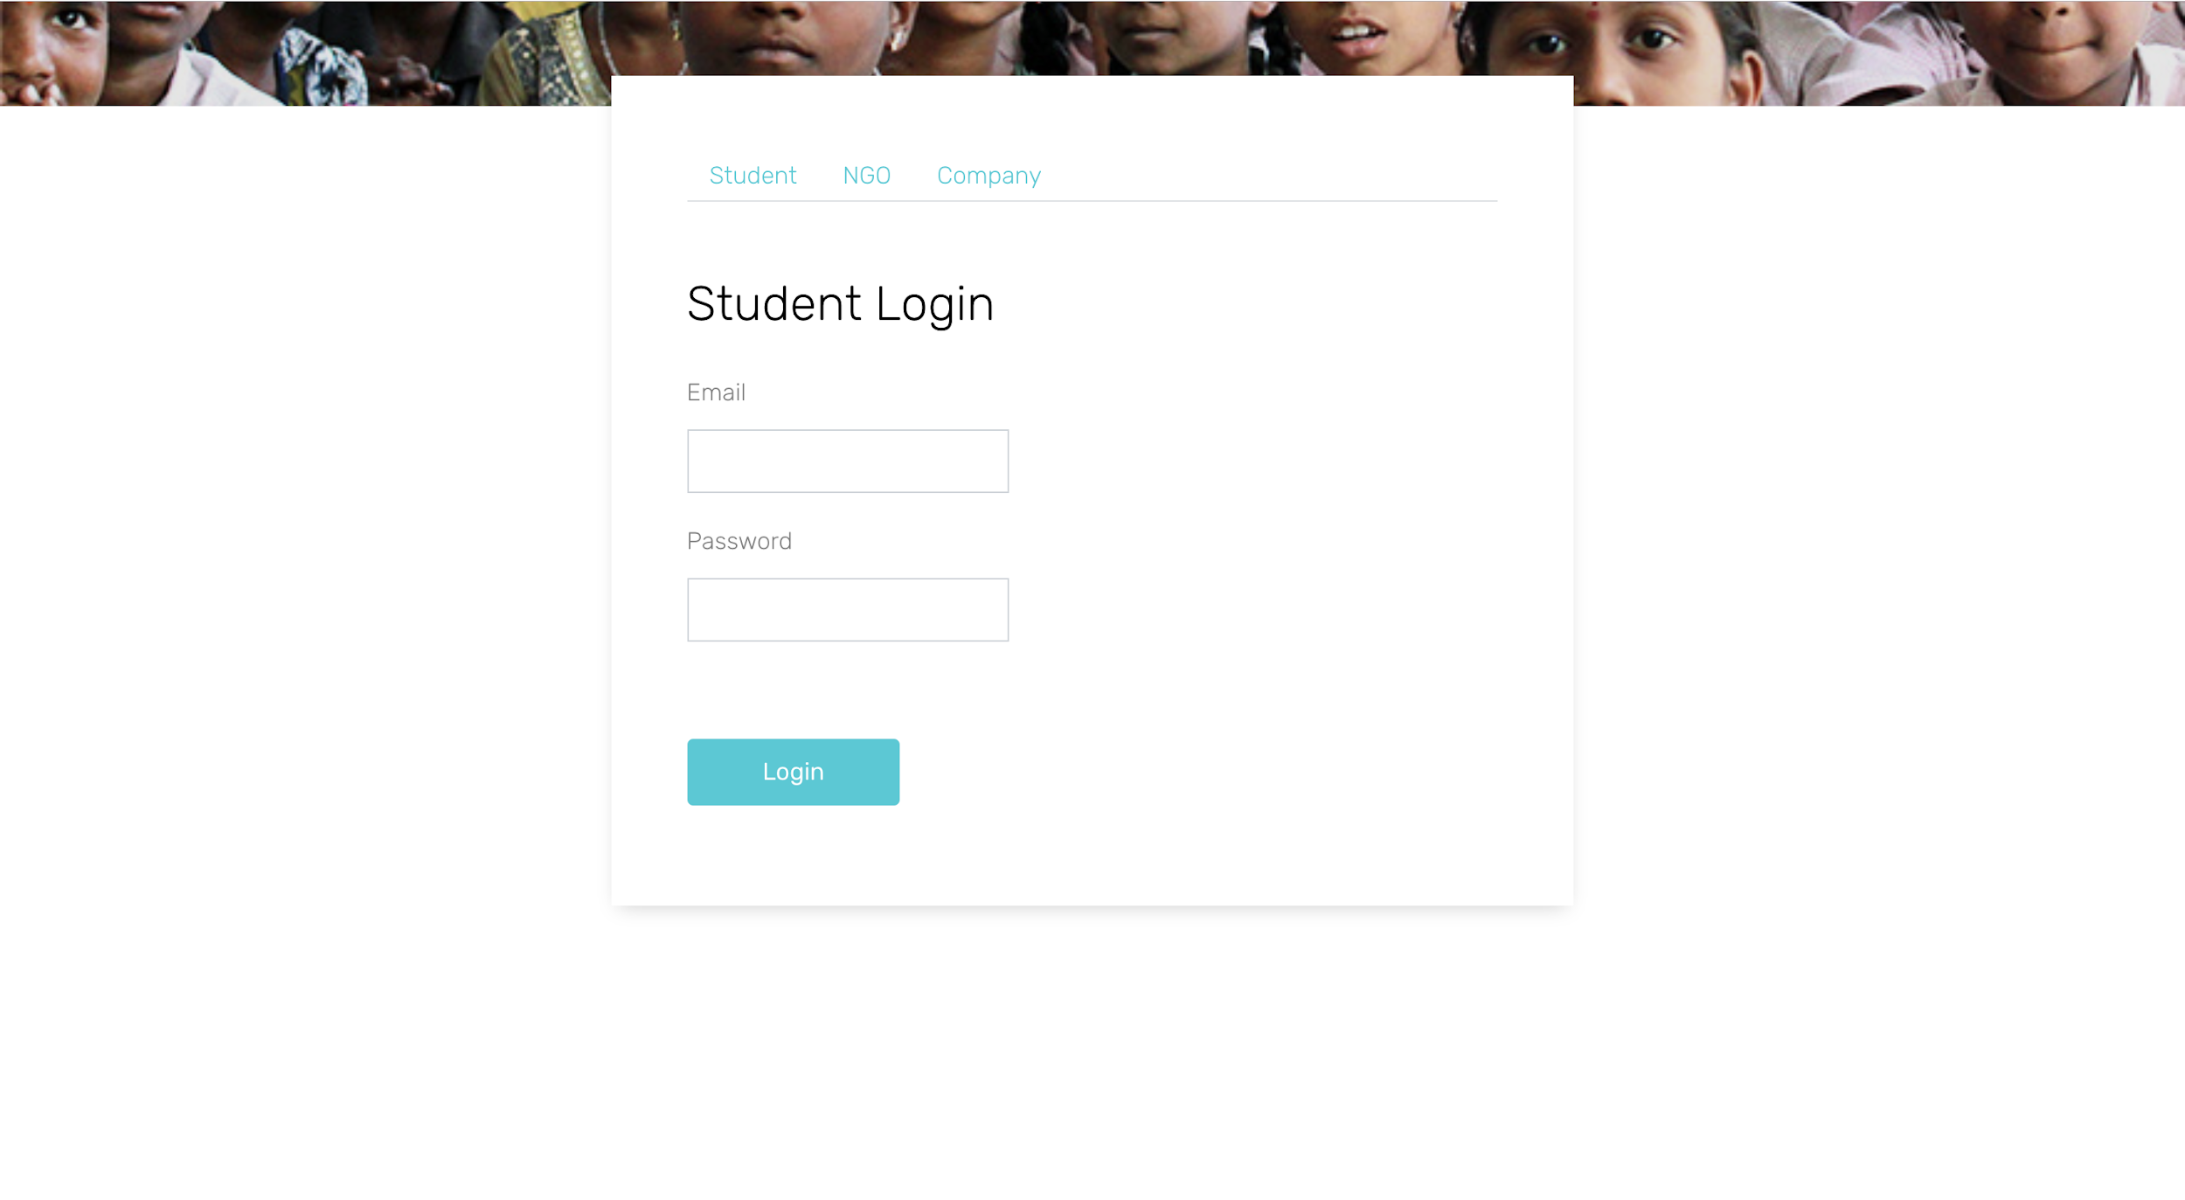

Figure 8: Student login page

|  |  |
| --- | --- |
| Parameter | Count |
| External Interface files | 0 |
| External Output | 0 |
| External Input | 0 |
| External Inquiry | 1 |

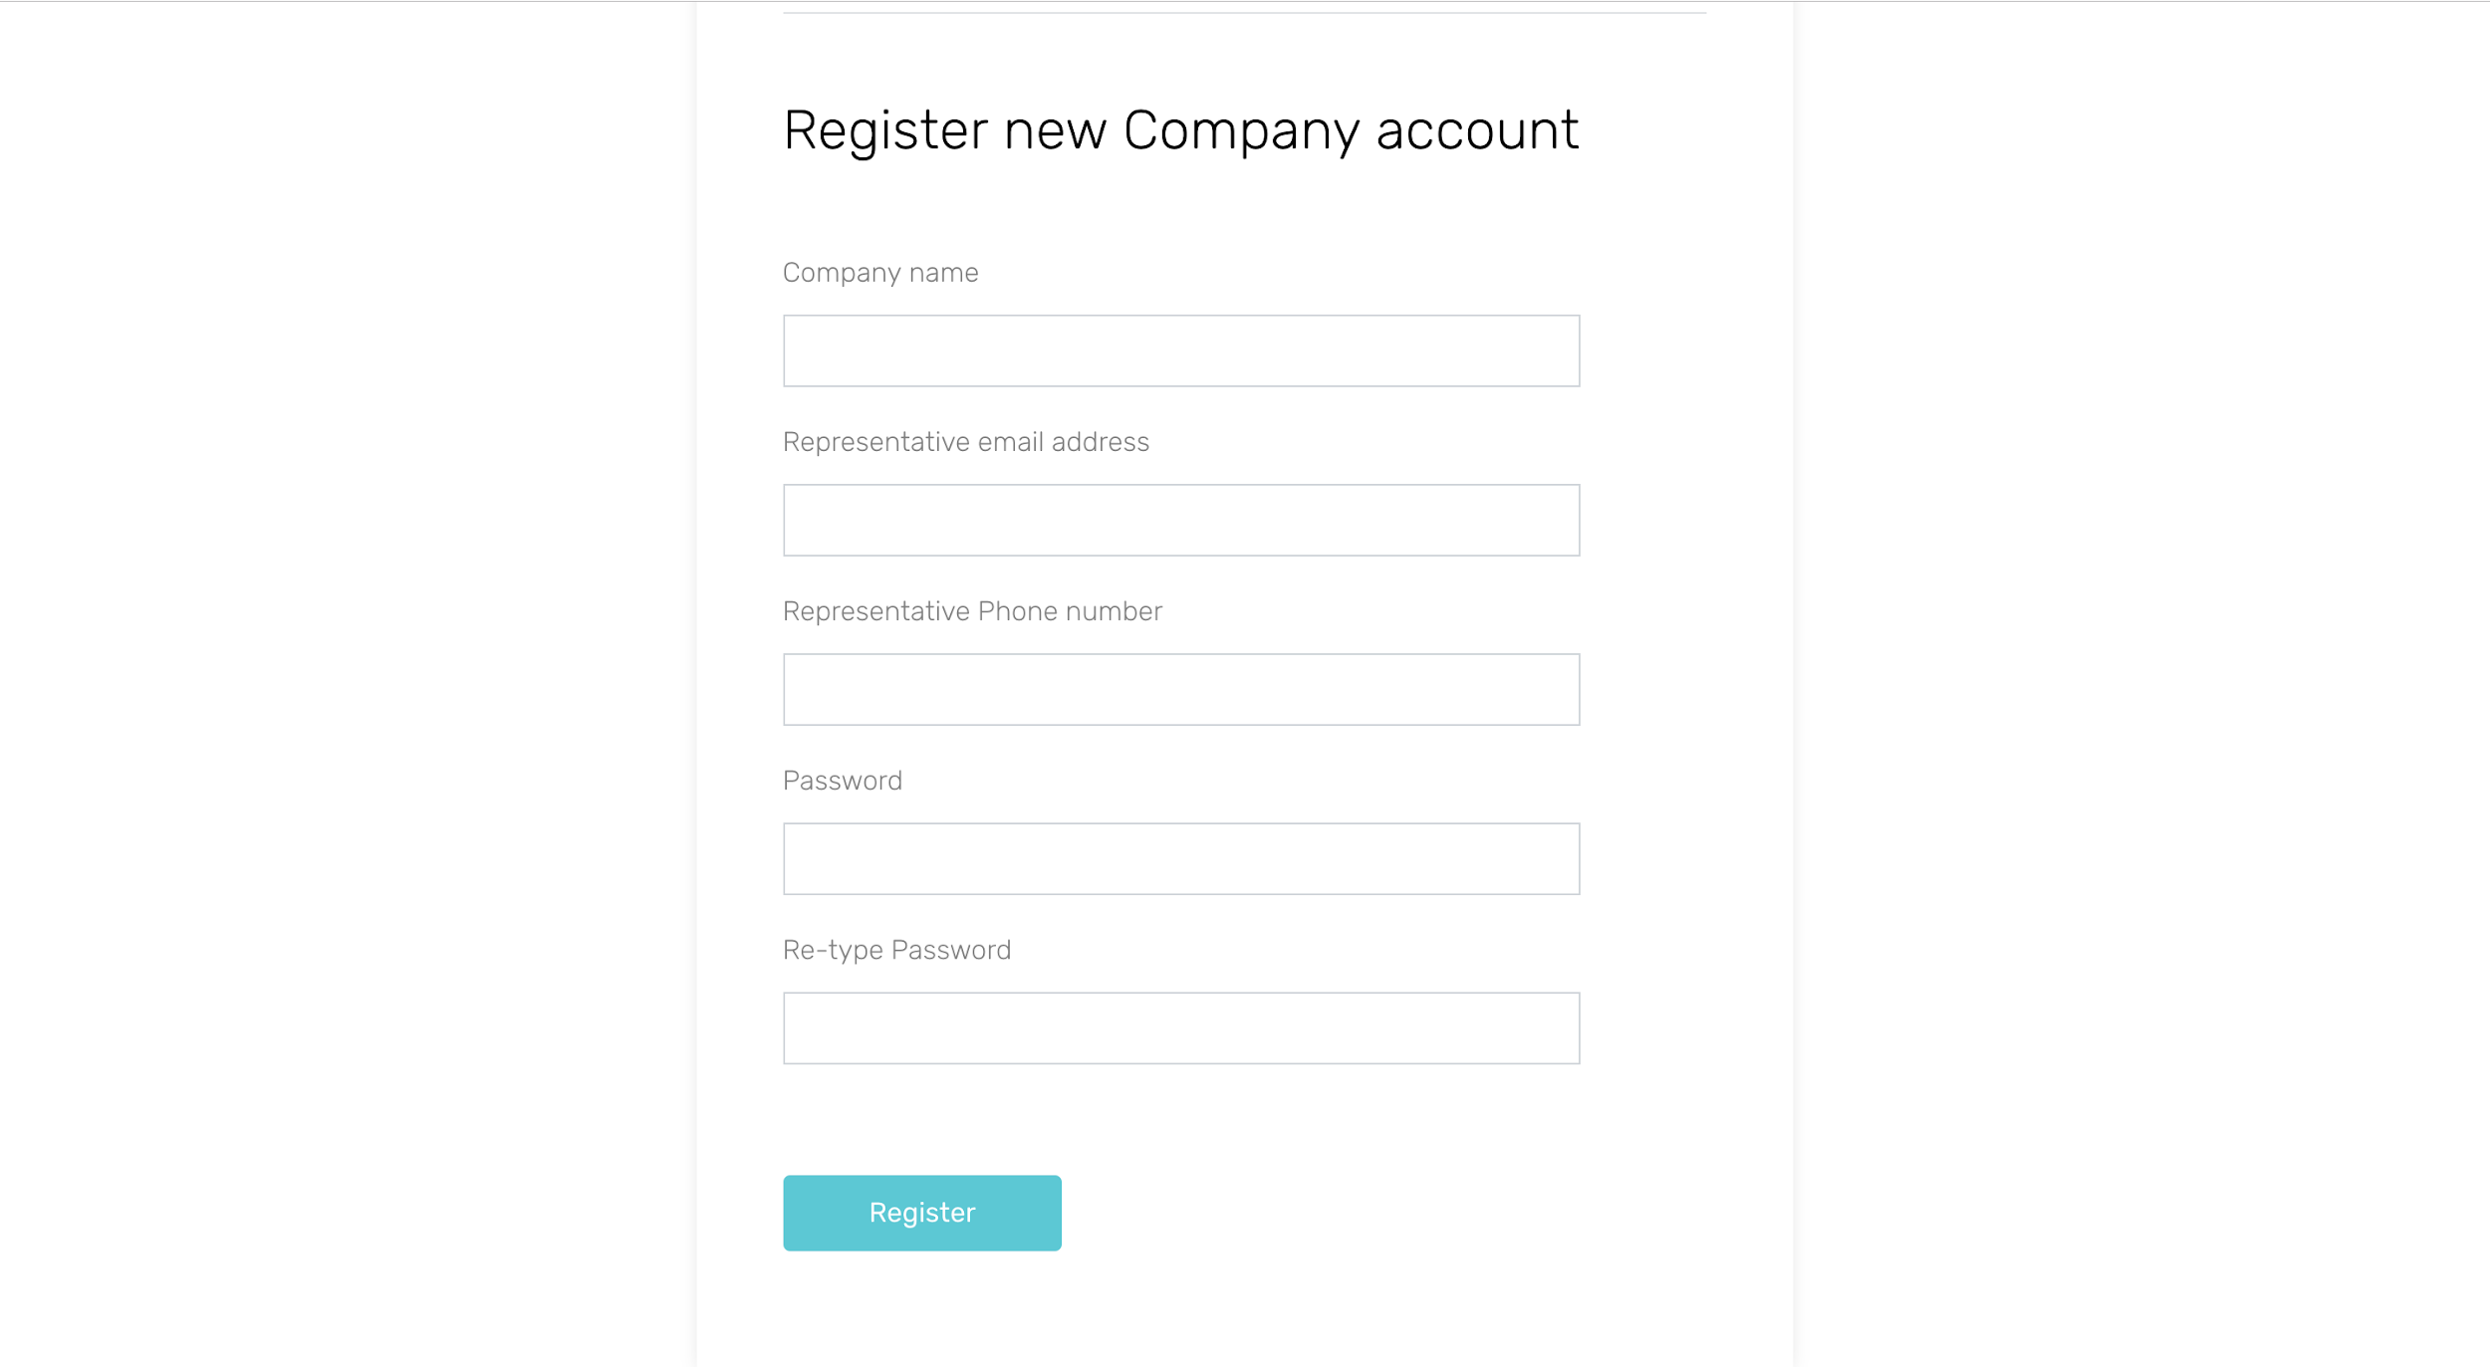

Figure 9: Registration page

|  |  |
| --- | --- |
| Parameter | Count |
| External Interface files | 0 |
| External Output | 0 |
| External Input | 1 |
| External Inquiry | 1 |

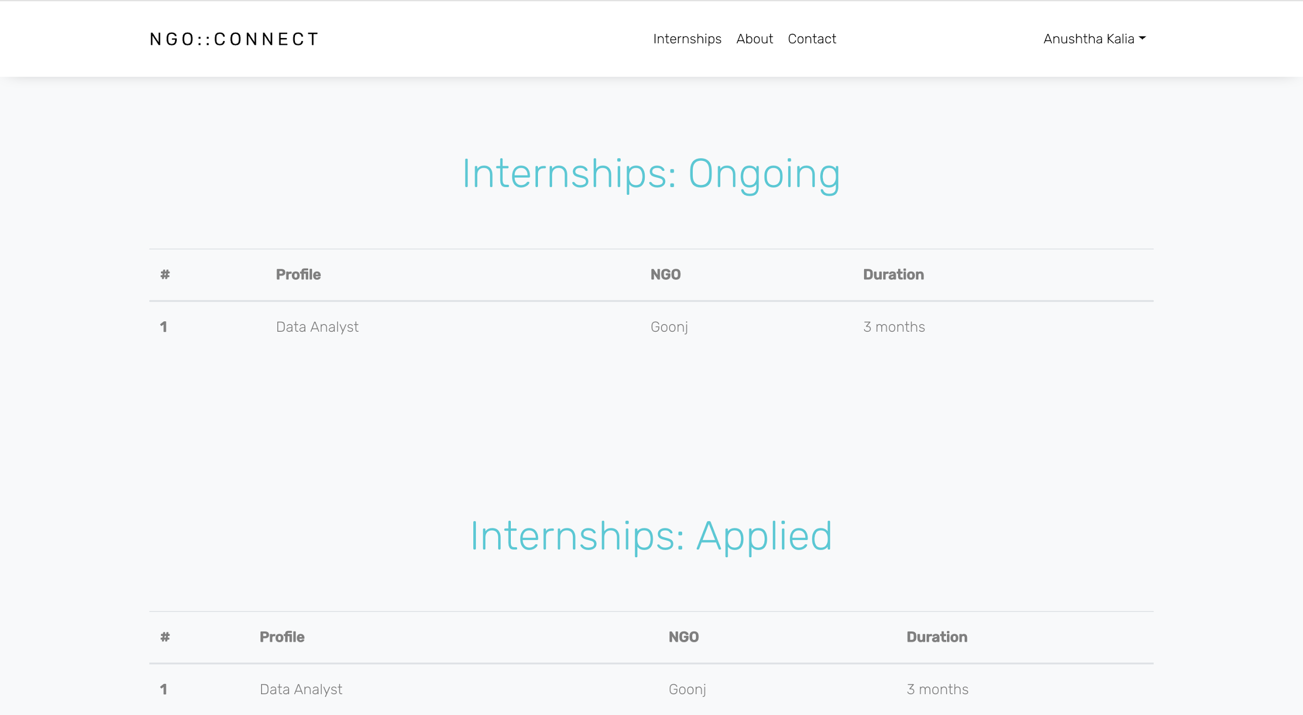

Figure 10: Student Dashboard

|  |  |
| --- | --- |
| Parameter | Count |
| External Interface files | 0 |
| External Output | 0 |
| External Input | 0 |
| External Inquiry | 4 |

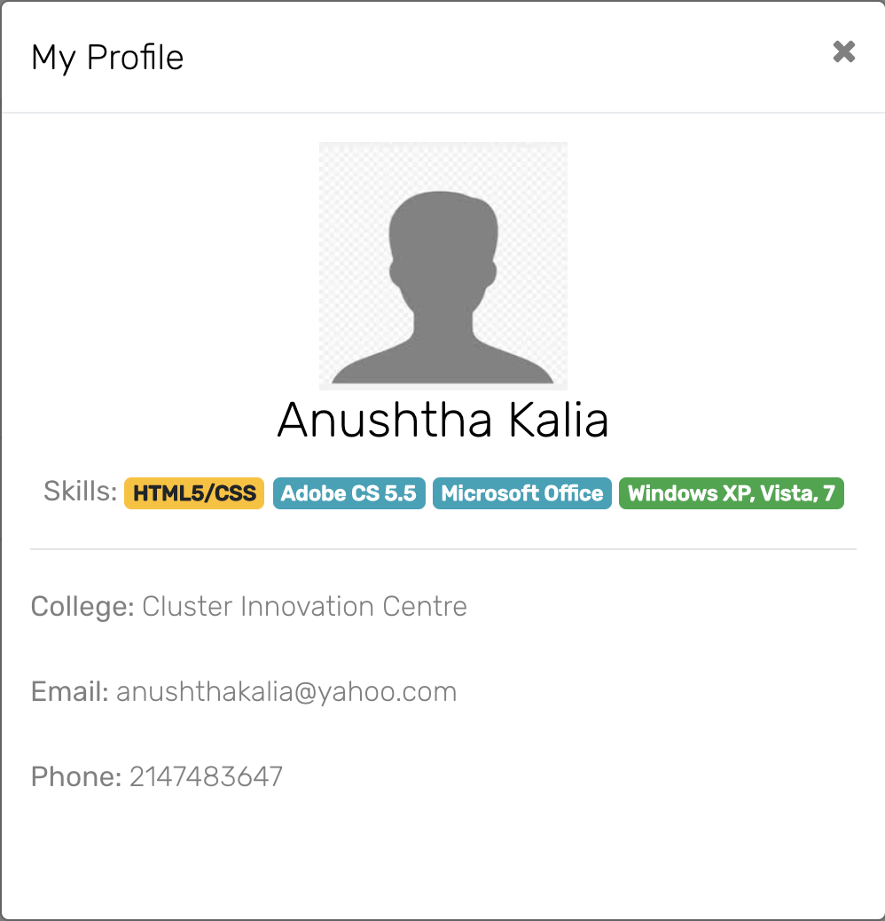

Figure 11: Student profile

|  |  |
| --- | --- |
| Parameter | Count |
| External Interface files | 0 |
| External Output | 0 |
| External Input | 0 |
| External Inquiry | 1 |

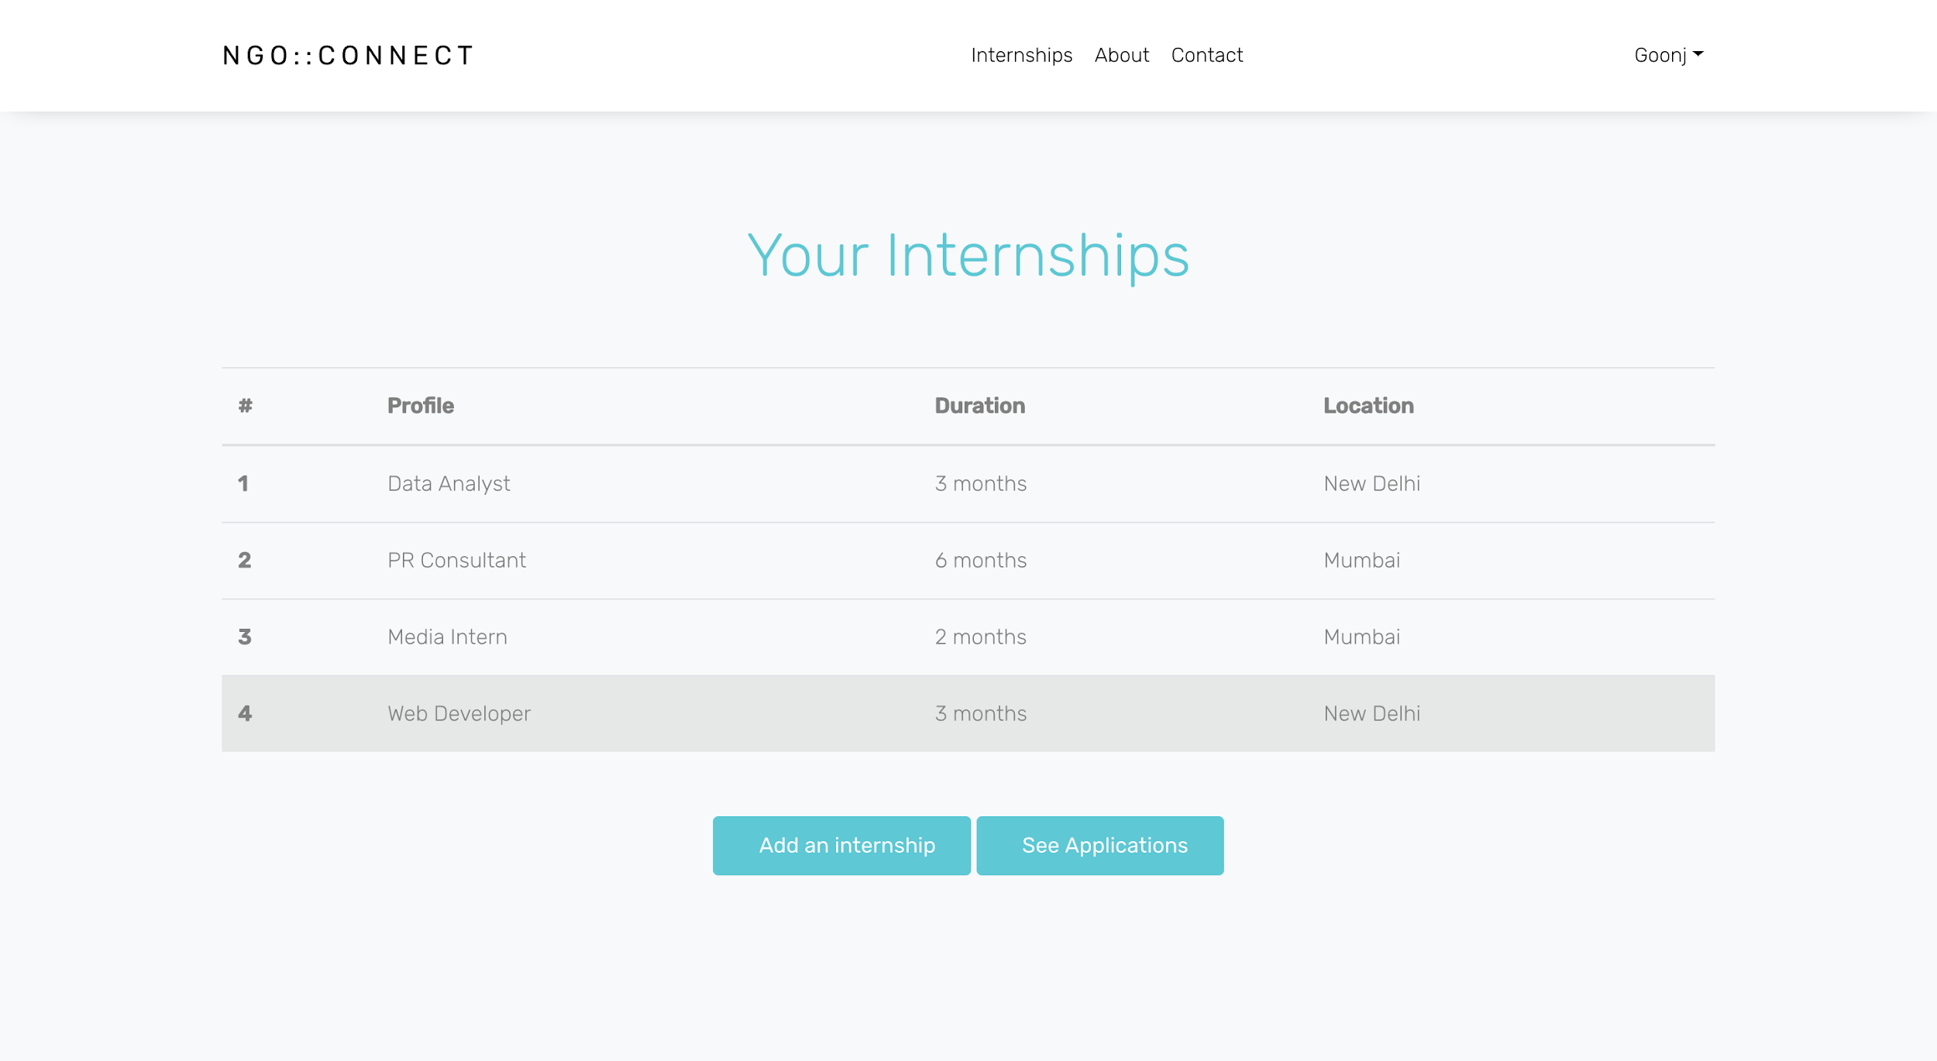

Figure 12: NGO dashboard

|  |  |
| --- | --- |
| Parameter | Count |
| External Interface files | 0 |
| External Output | 0 |
| External Input | 0 |
| External Inquiry | 4 |

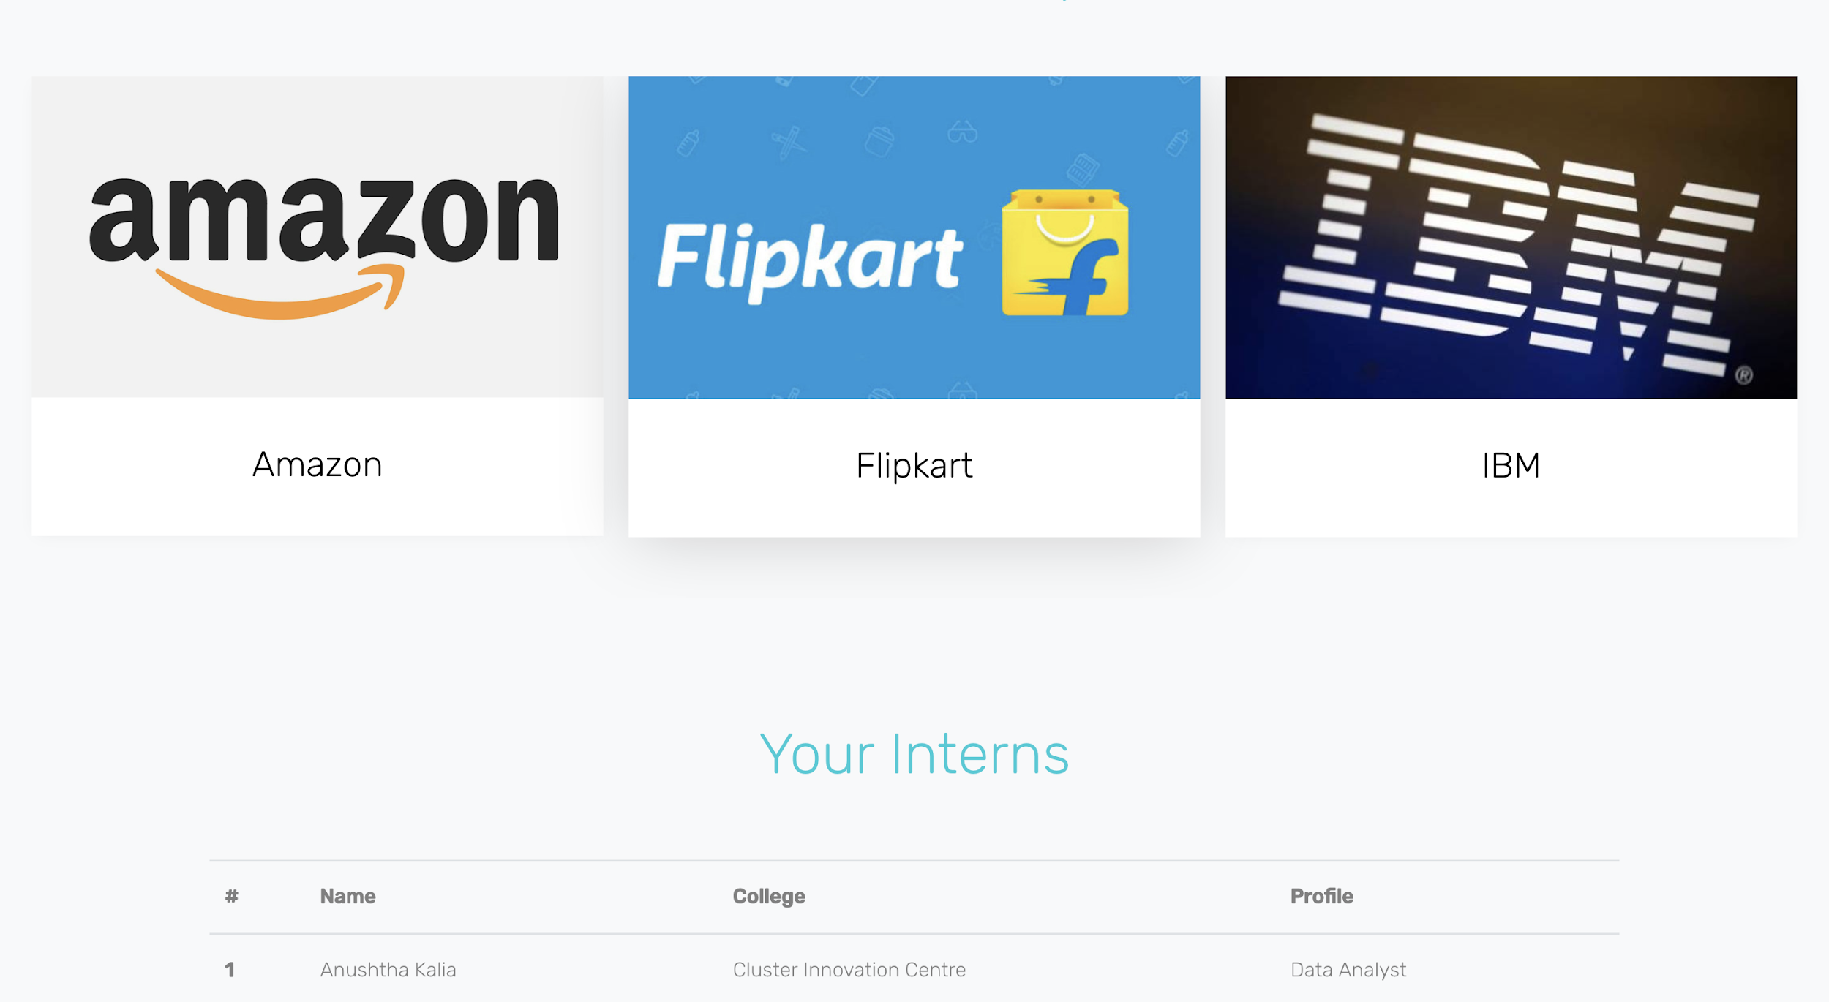

Figure 13: NGO dashboard

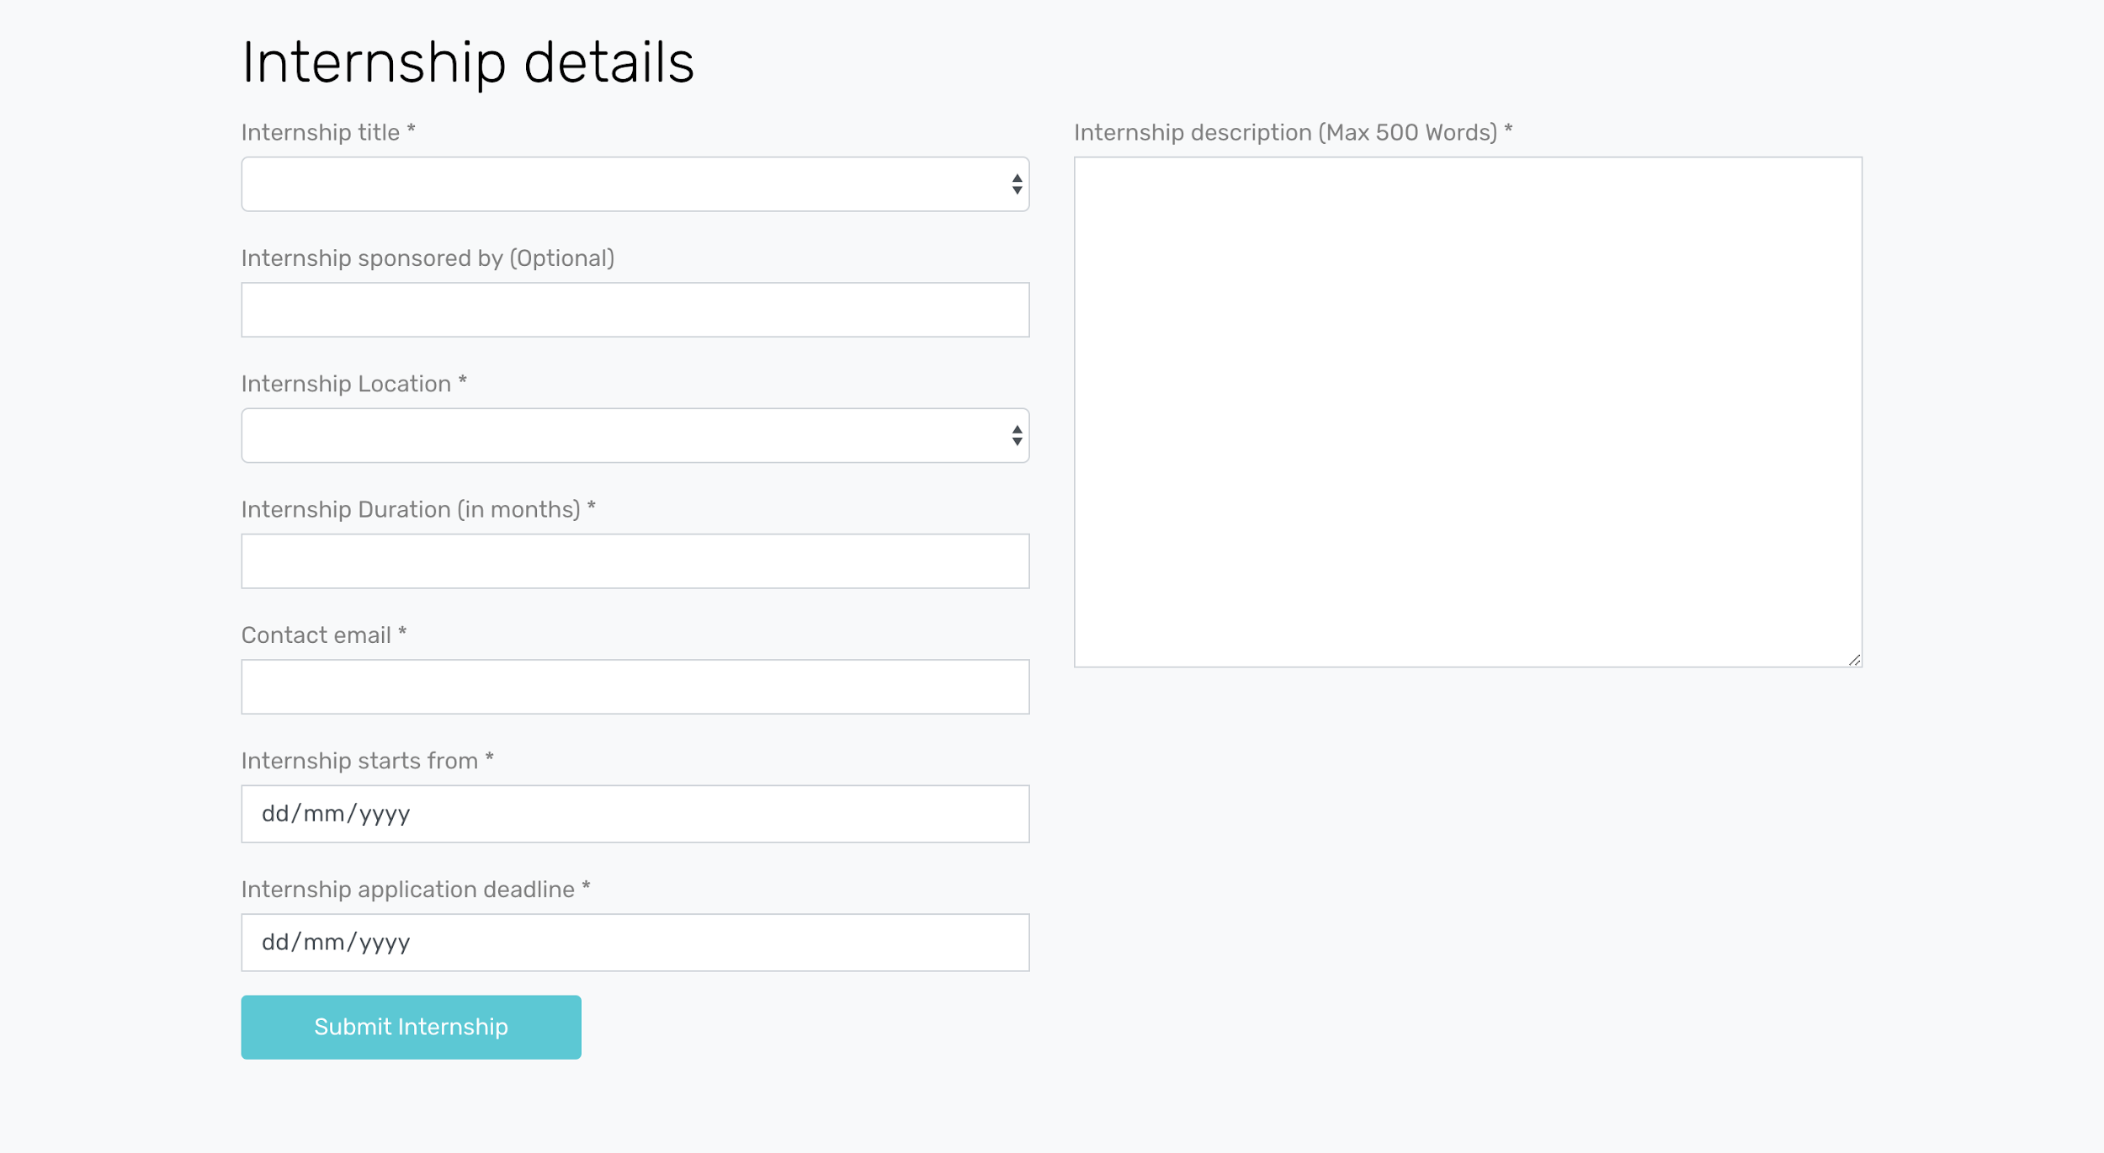

Figure 14: Add an internship form

|  |  |
| --- | --- |
| Parameter | Count |
| External Interface files | 0 |
| External Output | 0 |
| External Input | 1 |
| External Inquiry | 2 |

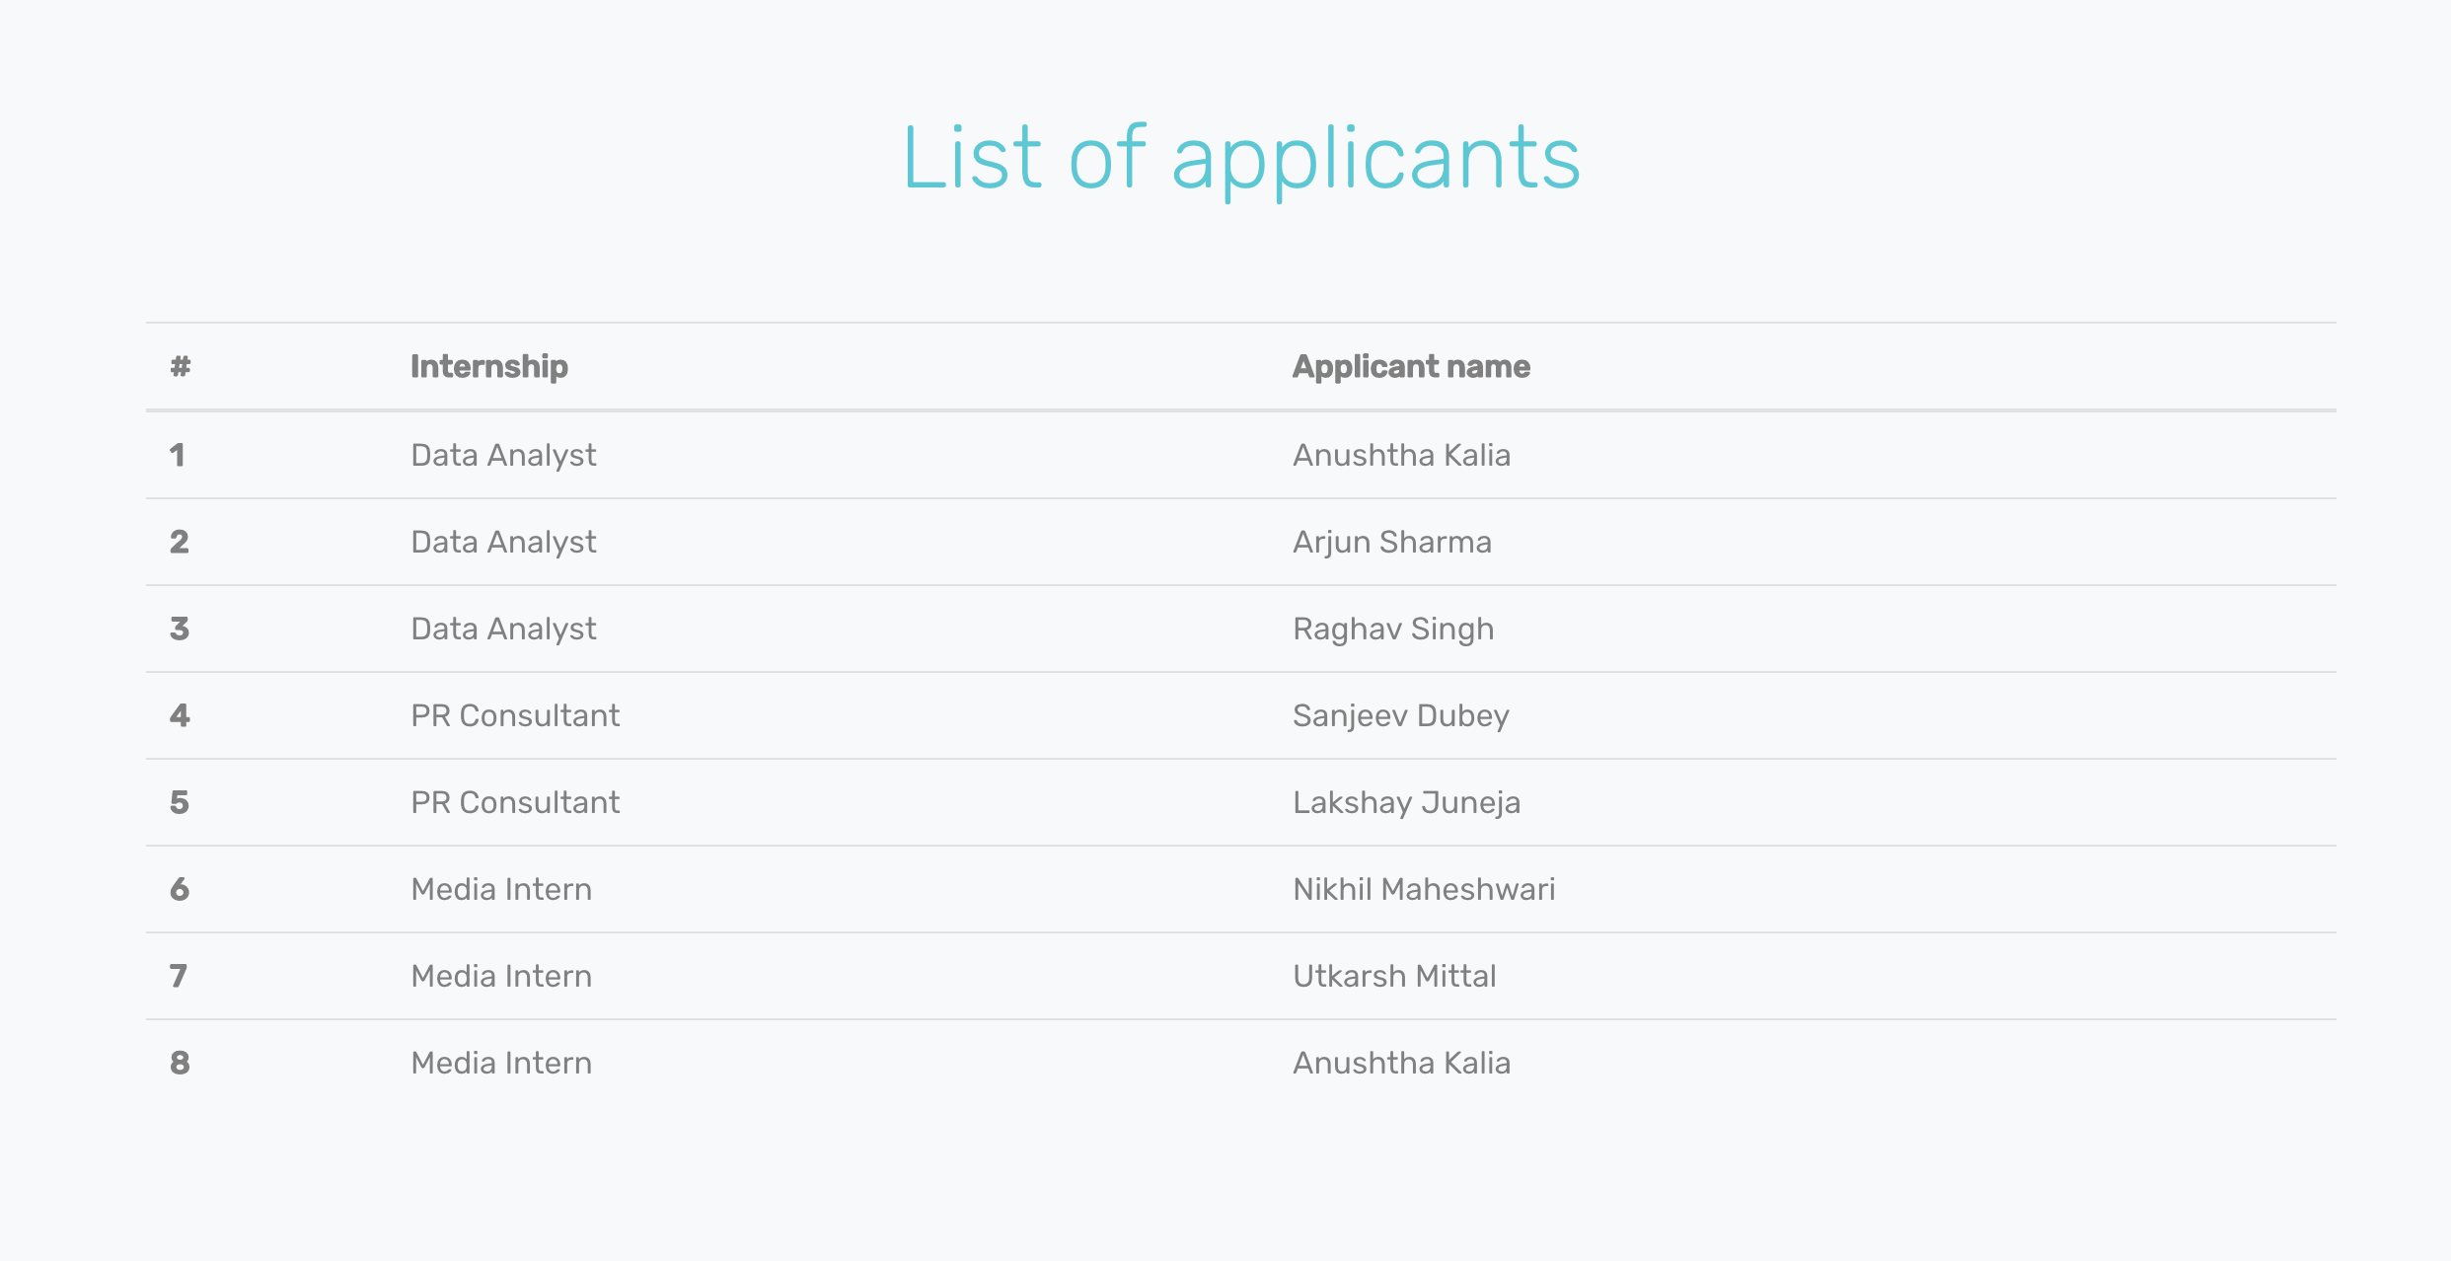

Figure 15: List of applicants for a particular internship

|  |  |
| --- | --- |
| Parameter | Count |
| External Interface files | 0 |
| External Output | 0 |
| External Input | 0 |
| External Inquiry | 4 |

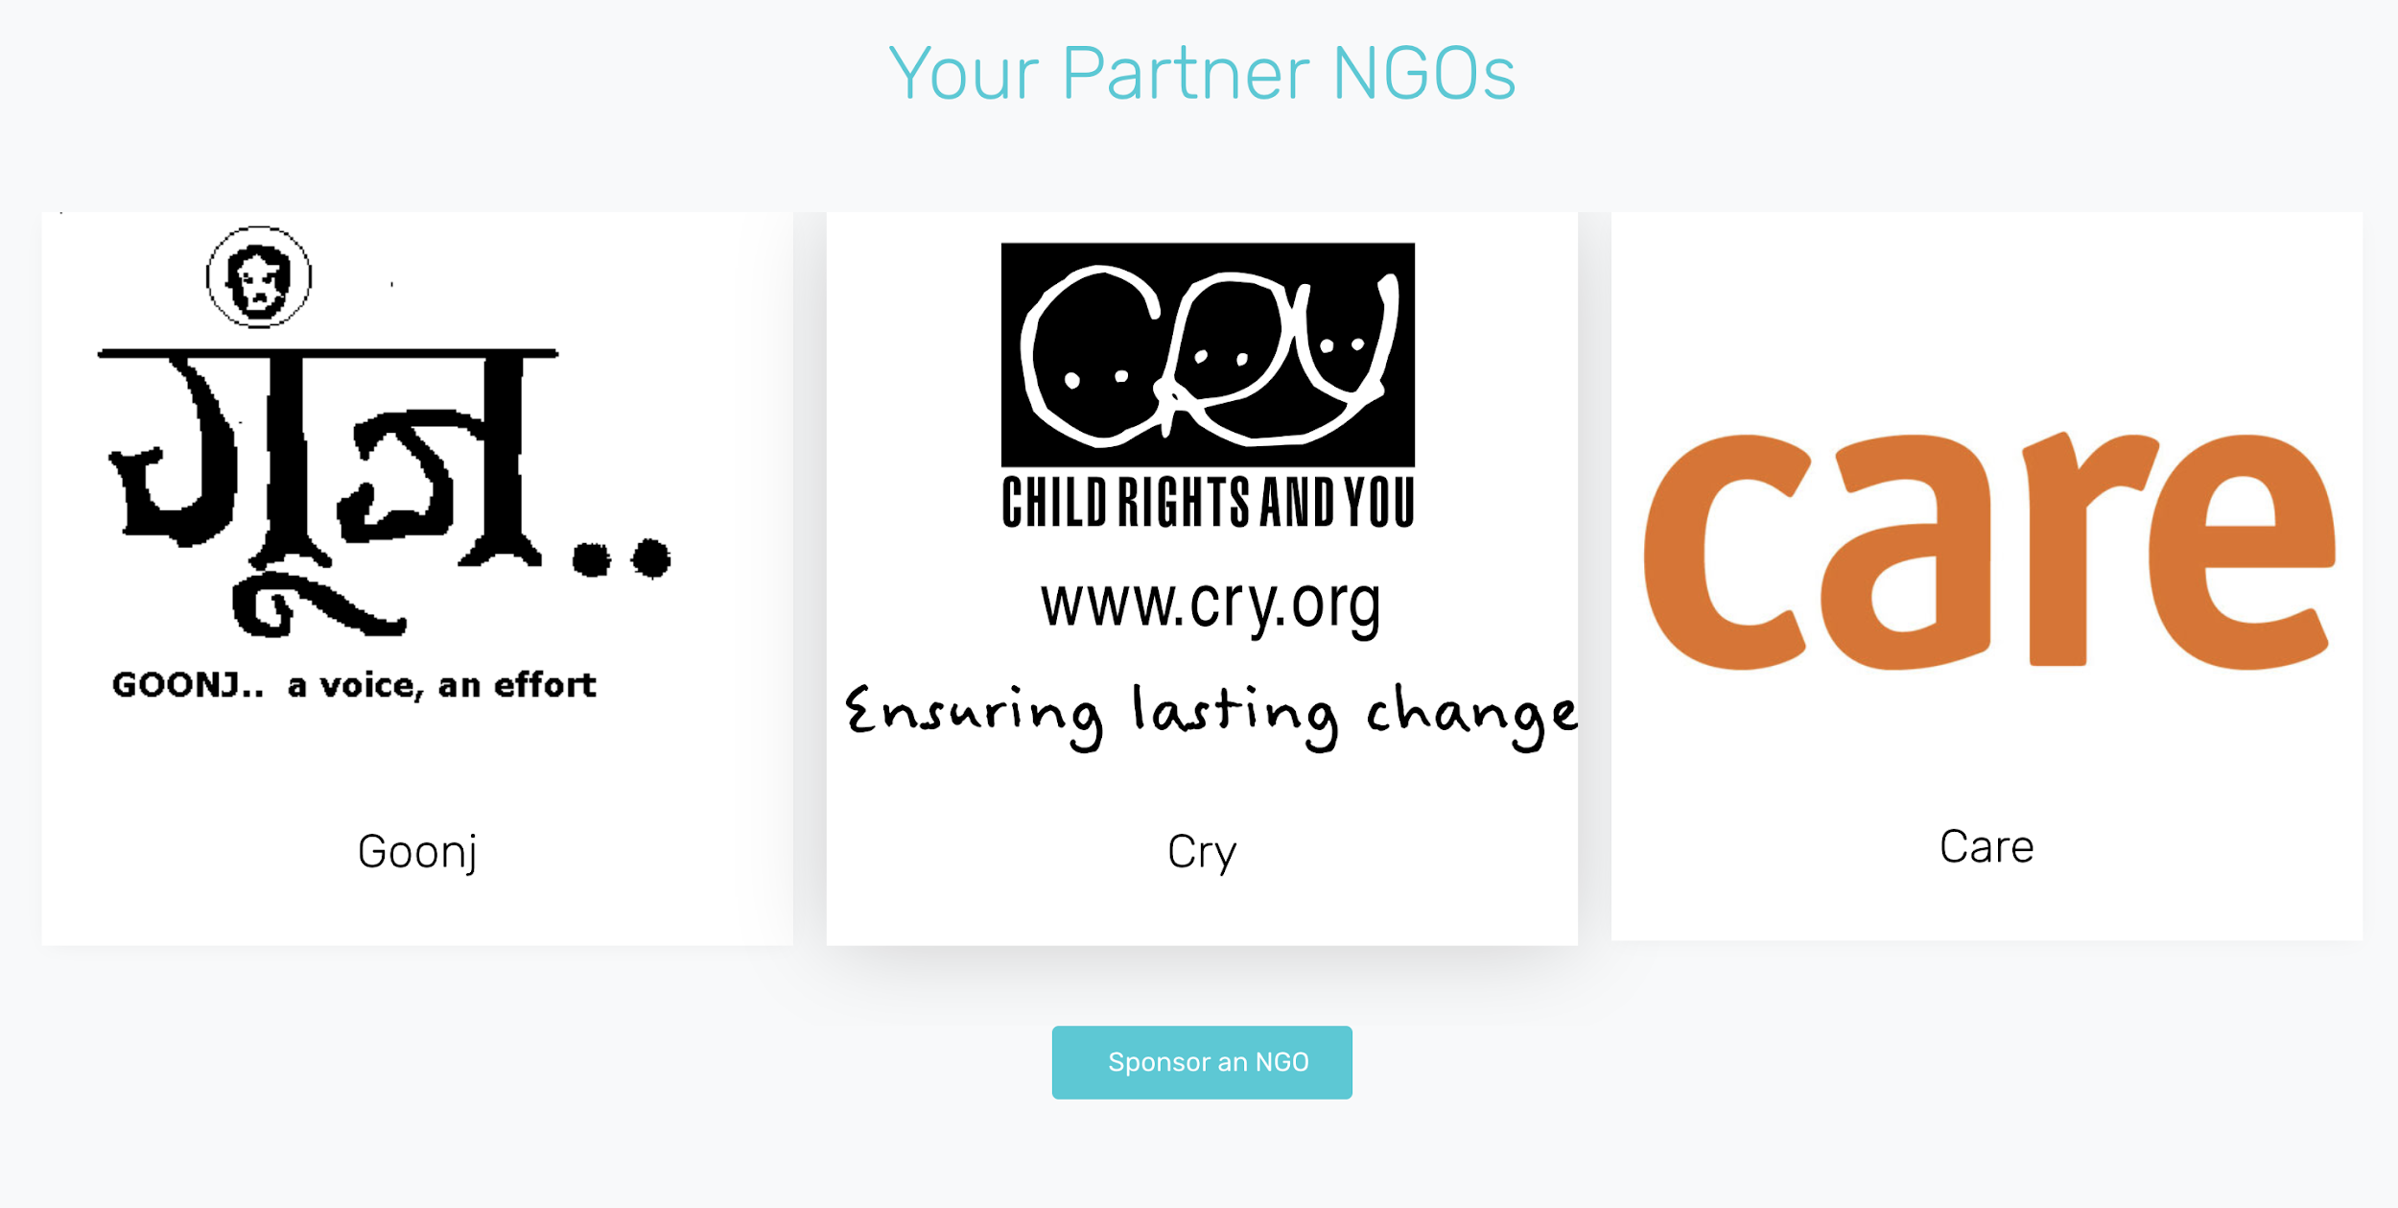

Figure 16: Company Dashboard

|  |  |
| --- | --- |
| Parameter | Count |
| External Interface files | 0 |
| External Output | 0 |
| External Input | 0 |
| External Inquiry | 2 |

#### 2.3.1.2 | Hardware Interfaces

Since the web portal does not have any designated hardware, it does not have any direct hardware interfaces.

#### 2.3.1.3 | Software Interfaces

The web portal communicates with the database in order to get information about the available internships.

The communication between the database and the web portal consists of operation concerning both reading (for the user panel) and modifying (for the admin panel) the data.

#### **2.3.1.4 |** **Communications Interfaces**

The communication between the different parts of the portal is important since they depend on each other. However, in what way the communication is achieved is not important for the system and is therefore handled by the underlying operating systems for the web portal.

### 2.3.2 | Functional Requirements

#### 2.3.2.1 | Login form

Introduction

It should contain 2 fields, one for username and the other for password and a login button. A link for forgot password should also be present. the login form for students, NGO and company is the same but on different buttons.

Inputs

1. Username – A maximum of 32 characters.

2. Password – A maximum of 32 characters.

Processing

It will fetch information from the database according to the username if it exists, and then match it with the password entered. If a match is found, the user will be granted access.

Outputs

A personalized homepage for the user.

Error Handling

Entries of length more than 32 characters are not allowed in the username and password fields.

If the entered username does not exist in the database, the login page is loaded again with username field marked with an error message “Username does not exist”.

If the password entered does not match with the username from the database, the login page is loaded again with password field marked with an error message “Incorrect Password”.

#### 2.3.2.2 | Registration Form

Introduction

The registration form has 3 modes of registration, one for the student, one for the NGO and one for the industry.

Inputs

Registration form for a student:

1. email address- valid email id
2. first name- initial name
3. surname- last name
4. phone number- valid phone number
5. college name- the institution of study
6. password- maximum 32 characters

Registration form for NGO:

1. email address - valid email id
2. NGO name - the name of the
3. address- valid address-house number/street/locality/district/state
4. registration number- registration number of the NGO
5. password- maximum 32 characters

Registration form for the company:

1. company name- the name of the company
2. registered phone number - valid phone number
3. email address- valid email id
4. password- maximum 32 characters

Processing

It will store the information of a new user into the database according to the username (unique) if the username selected by the new user does not exist in the database. The user will be granted access to a personalized homepage.

Outputs

A personalized homepage for the new student, NGO and the company.

Error Handling

Entries of length more than 32 characters are not allowed in the username and password fields.

If the username chosen by the new user already exists in the database, the registration page is loaded again with username field marked with an error message “Username already taken”.

New users can choose their pin code only from a given set, thus completely removing the chances of a wrong pin code in the delivery address

#### 2.3.2.3 | Adding an internship as an NGO :

Introduction

The internship addition form makes the NGO add the tasks which are supposed to be mentioned as the details for the internship.

Inputs

1. internship title: the title of the internship is added here.
2. internship sponsored by: It is an optional field and sponsor name is added to it.
3. internship location: location of internship
4. internship duration: duration of the internship
5. contact email: email address is mentioned here
6. internship start date: the start date of the internship is mentioned here
7. internship application deadline: The deadline for the application is mentioned in this column.

Processing

All these inputs are added into the database and are then displayed onto the internships page.

Outputs

A screen is displayed which shows that the internship has been uploaded in the database.

#### 2.3.2.4 | Apply for an internship by a student

Introduction

In this section, the student goes to the internship and clicks on the apply button, through which the intern information is sent to the NGO.

Inputs

1. login: login as a student
2. password: password for login
3. apply button: apply button to apply for the internship

Processing

The inputs are stored in the database so that the NGO can view the internship detail of the student on its dashboard.

Output

The apply button changed to applied, the student’s dashboard is updated with regard to the internship, and also the NGO is updated about the student details.

#### 2.3.2.5 | Search engine

Introduction

In this section, the search engine is implemented onto the home page, through which you can search through any amount of keywords.

Inputs

1. Search bar: it is where the keyword is inserted and is the only component of the search engine, rest all is implemented from the SQL query.

Processing

It is actually an SQL query through which the keyword is searched and the output is displayed accordingly.

Outputs

The inserted keyword is searched and the output is fetched to whatever page the keyword is associated with.

### 2.3.3 | Use Cases

#### **2.3.3.1 | Use Case 1**

|  |  |
| --- | --- |
| Use Case Name | Listing internships on the portal |
| Participating Actors | NGO |
| Flow of Events | 1. Logs on to their respective homepage. 2. Enter all the details of the new internship like time-period, skills required, perks etc. 3. Save the details on to the database |
| Alternative Flows | 2.a. User does not have the permissions to add entries to the database.  2.b. User requests for admin rights to enter data into the database and exits for now.  3.a. Internship already exists on the database.  3.b. User exits without altering the database. |
| Entry Conditions | User has privileges to enter internship related data into the database and internship does not exist already. |
| Exit Conditions | User adds more information onto the system or leaves the admin panel due to lack of required privileges |

Table 3: Use case 1

## 

## 

## 

## 

#### 2.3.3.2 | Use Case 2

|  |  |
| --- | --- |
| Use Case Name | Applying to a listed internship |
| Participating Actors | Student |
| Flow of Events | 1. Logs on to their respective homepage. 2. Enter the relevant details. 3. Submit the application. |
| Alternative Flows | 2.a. User is not eligible (due to lack of skills).  2.b. User requests for permission to apply and exits for now.  3.a. Application has already been submitted.  3.b. User exits without duplicating the applications in the database. |
| Entry Conditions | User has skills to apply for internship into the database and has not already submitted an application for that internship. |
| Exit Conditions | User successfully applies for the internship or leaves the application portal due to lack of supporting skillset. |

Table 4: Use case 2

## 

## 

## 

## 

## 

#### 2.3.3.3 | Use Case 3

|  |  |
| --- | --- |
| Use Case Name | Logging onto NGO connect |
| Participating Actors | User (Student/NGO/Corporate) |
| Flow of Events | 1. Opens Login page. 2. Enter the required details like email and password. 3. Access their personal homepage. |
| Alternative Flows | 2.a. User does not have a password to logon to the website..  2.b. User registers themselves onto the website by filling out some details and generate a password for logging in. |
| Entry Conditions | User has already registered themselves with NGOconnect and have credentials to login. |
| Exit Conditions | User credentials match with stored in the database and they’re able to access their homepage. |

Table 5: Use case 3

#### 2.3.3.4 | Use Case 4

|  |  |
| --- | --- |
| Use Case Name | Partnering with an NGO |
| Participating Actors | Corporate |
| Flow of Events | 1. Open the list of all the registered NGOs. 2. Read more details about a particular NGO. 3. Request to partner with that NGO. |
| Entry Conditions | User has already registered themselves with NGOconnect and is interested in partnering with one or more NGOs. |
| Exit Conditions | Successfully submit request for partnering. |

Table 6: Use case 4

### 

### 2.3.4 | Non-Functional Requirements

#### 2.3.4.1 | Performance

The product should give the best performance on a desktop, and system downtime should not exceed a minute per day.

#### 2.3.4.2 | Reliability

It refers to the reliability that the portal gives the right result on a search. Considering that 1000 searches are conducted during testing, at least 98% should be accurate.

#### 2.3.4.3 | Availability

It refers to the availability of the portal when it is used. The average portal availability should be more than 98% of the time.

#### 2.3.4.4 | Security

Appropriate steps in order to prevent SQL injection in the text boxes need to be taken as and when required.

#### 2.3.4.5 | Maintainability

The portal should be easy to extend. The code should be written in a way that it favors implementation of new functions. Also, test environments should be built for the portal to allow testing of the portal’s different functions.

#### 2.3.4.6 | Portability

The portal should be able to run on desktops, mobile phones, tablets and any other such devices.

### 2.3.5 | Inverse Requirements

*Not Applicable*

### 2.3.6 | Design Constraints

Since the portal will run on the web browser, no specific design constraints exist. It is only the compatibility with the browser that needs to be taken care of.

### 2.3.7 | Logical Database Requirements

A database is required in order to store information related to students, NGOs, corporates & various internships. The portal will display the different results according to results fetched via different queries from the database.

## 2.4 | Analysis Model

### 2.4.1 | Context Free Diagram

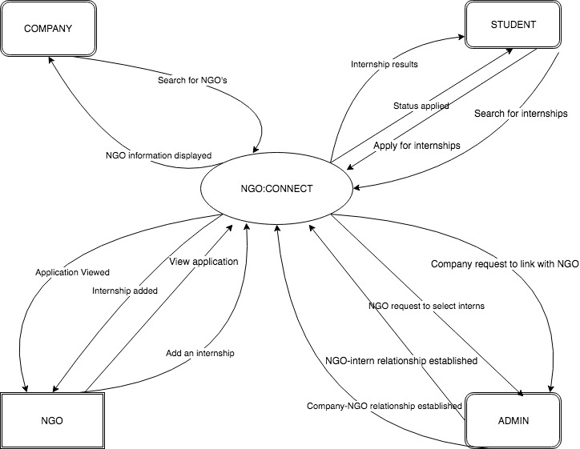

Figure 17: Context free Diagram for the project

### 2.4.2 | Data Flow Diagram

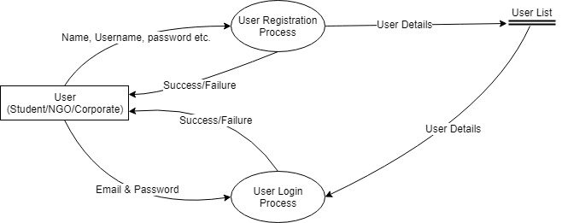

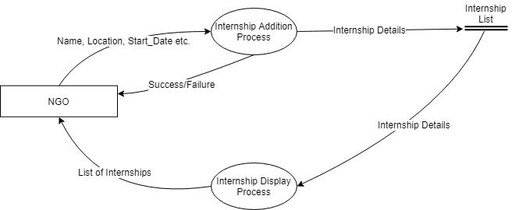

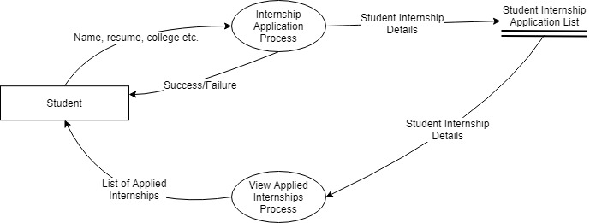

Figure 18: Data flow diagram for all three parties

### 

### 

### 2.4.3 | Architecture Diagram

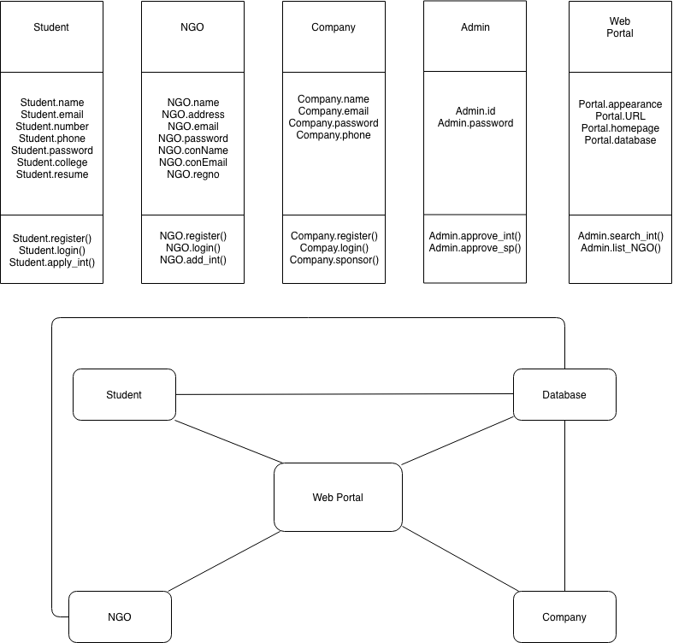

Figure 19: Architecture Diagram for the project

### 2.4.4 | State Transition Diagram

Figure 20: State Transition Diagram for the Project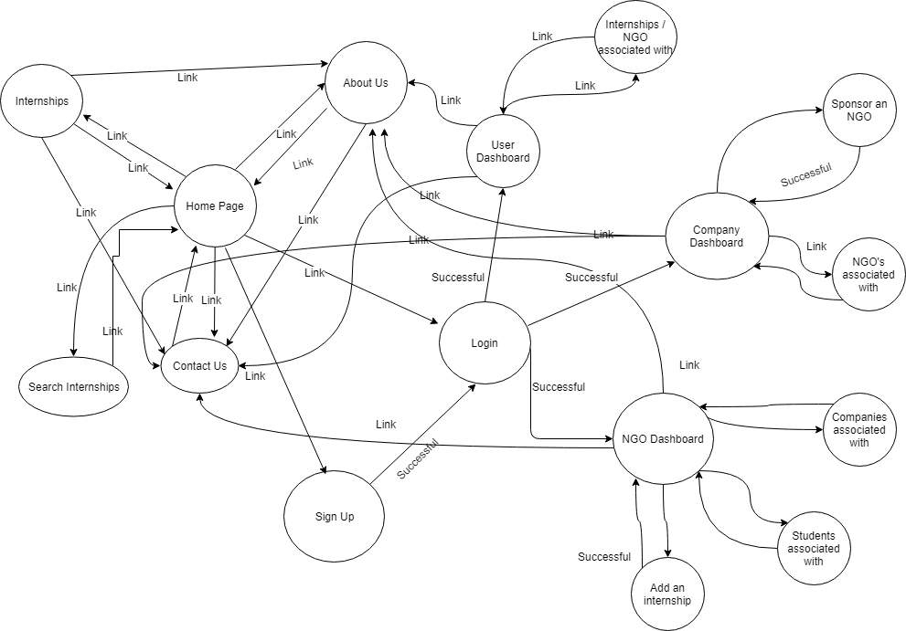

### 

### 2.4.5 | Structure Chart

#### 2.4.5.1 | Student Registration

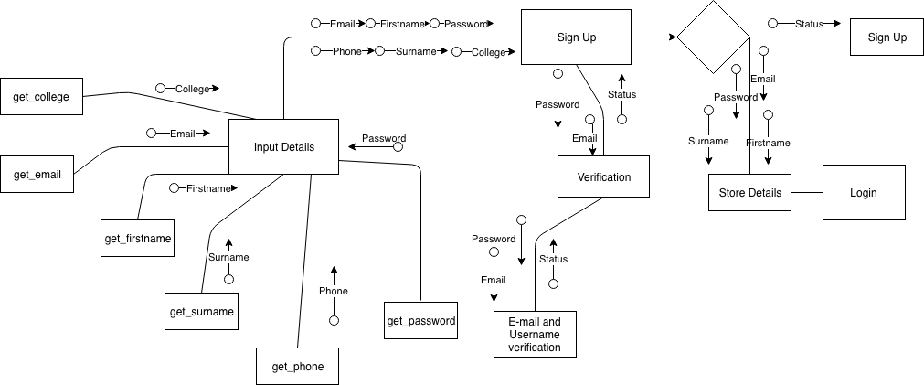

Figure 21: Structure chart for student registration

**2.4.5.2 | Internship addition**

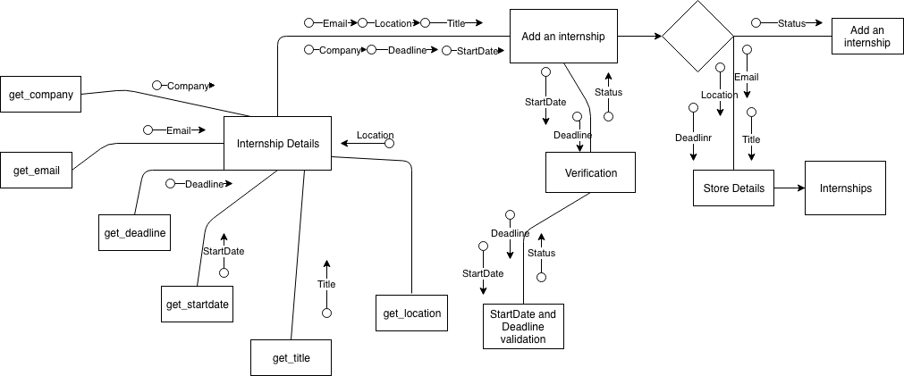

Figure 22: Structure chart for internship addition

**2.4.5.3 | Apply to an internship**

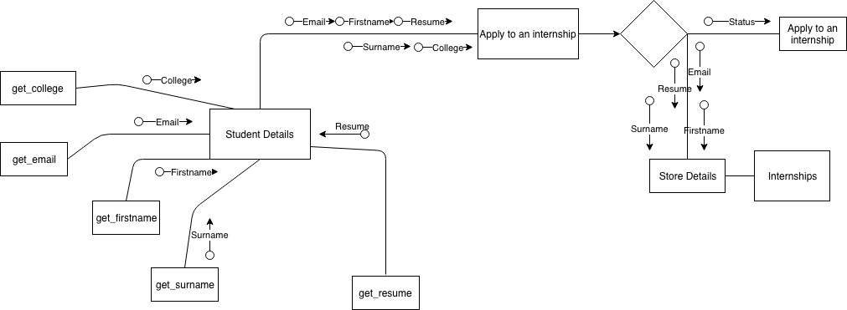

Figure 23: Structure chart for internship application

# 3 | Entity Relationship Diagram

# 

# 

Figure 24: ER diagram for the project

# 

# 4 | Data Dictionary

**Company**

|  |  |  |  |
| --- | --- | --- | --- |
| **Data Item** | **Type** | **Description** | **Comment** |
| comid | int | id of company | primary key |
| email | varchar | email address |  |
| password | varchar | password of email |  |
| comname | varchar | company name |  |
| phone | int | phone number |  |
| fk_ngo_id | int | id of ngo aligned | foreign key |

Table 7: Data dictionary for company

**Internship Details**

|  |  |  |  |
| --- | --- | --- | --- |
| **Data Item** | **Type** | **Description** | **Comment** |
| internship_id | int | id for internship | primary key |
| Name | varchar | name of internship |  |
| NGO | varchar | name of ngo |  |
| Company | varchar | name of company |  |
| internship_descr | text | description of internship |  |
| Location | varchar | location of internship |  |
| Start_date | varchar | start date of internship |  |
| Duration | varchar | duration of internship |  |
| Apply_by | date | apply date |  |
| Tags | varchar | tags associated |  |
| fk_intern_select_id | int | intern id | foreign key |
| fk_ngo_id | int | ngo id | foreign key |

Table 8: Data dictionary for internship details

**NGO**

|  |  |  |  |
| --- | --- | --- | --- |
| **Data Item** | **Type** | **Description** | **Comment** |
| ngoid | int | id of the ngo | primary key |
| email | varchar | email of ngo |  |
| password | varchar | password of email |  |
| ngoname | varchar | name of ngo |  |
| address | varchar | address of ngo |  |
| contactname | varchar | name of contact |  |
| contactemail | varchar | email of contact |  |
| regno | varchar | registration no of ngo |  |
| fk_comid | int | company id | foreign key |

Table 9: Data dictionary for NGO

**Student**

|  |  |  |  |
| --- | --- | --- | --- |
| **Data Item** | **Type** | **Description** | **Comment** |
| id | int | id of the student | primary key |
| password | varchar | password of the student |  |
| firstname | varchar | initial name |  |
| surname | varchar | last name of student |  |
| email | varchar | email address |  |
| college | text | college name |  |
| phone | int | phone number |  |
| resume | varchar | resume uploaded of the student |  |
| fk_ngo_id | int | ngo id associated | foreign key |
| fk_internship_details_select_id | int | internship details | foreign key |

Table 10: Data dictionary for student

**Student_internship_apply**

|  |  |  |  |
| --- | --- | --- | --- |
| **Data Item** | **Type** | **Description** | **Comment** |
| apply_id | int | id of application | primary key |
| fk_intern_id | int | intern id | foreign key |
| fk_internship_details_id | int | internship id | foreign key |

Table 11: Data dictionary for student_internship_apply

# 5 | Function Point metrics

Function-oriented software metrics use a measure of the functionality delivered by the application as a normalization value. Function point measures functionality from the user’s point of view, that is, on the basis of what the user requests and receives in return from the system. Since ‘functionality’ cannot be measured directly, it must be derived indirectly using other direct measures. Function points are derived using an empirical relationship based on countable measures of software’s information domain and assessments of software complexity.

Functions points are computed by completing the five information domain characteristics are determined and counts are provided in the appropriate table location. Information domain values are defined in the following manner:

**Number of user inputs.** ​​Each user input that provides distinct application-oriented data to the software is counted. Inputs should be distinguished from inquiries, which are counted separately.

**Number of user outputs**​​**.** Each user output that provides application-oriented information to the user is counted. In the context output refers to reports, screens, error messages, etc. individual data items within a report are not counted separately.

**Number of user inquiries**​​**.** An inquiry is defined as an on-line input that results in the generation of some immediate software response in the form of an on-line output. Each distinct inquiry is counted.

**Number of files**​​. Each logical master file (i.e., a logical grouping of data that may be one part of a large database or a separate file) is counted.

**Number of external interfaces**​​**.** ​​All machine-readable interfaces (e.g., data files on storage media) that are used to transmit information to another system are counted.

Once these data have been collected, a complexity value is associated with each count. Organizations that use function point methods develop criteria for determining whether a particular entry is simple, average, or complex. Nonetheless, the determination of complexity is somewhat subjective.

To compute function points (FP), the following relationship is used:- FP=count total x [0.65+0.01 x ∑ (F​i)​ ]

Function points table

Average values have been assumed as weights for the five parameters:

|  |  |  |
| --- | --- | --- |
| Measurement Parameter | Count | Weight |
| External Inputs | 5 | 4 |
| External Outputs | 0 | 5 |
| External Inquiry | 41 | 4 |
| External Interfaces | 0 | 7 |
| Internal Logical Files | 5 | 10 |

Table 12: Function point metrics table

Count total = 5 X 4 + 0 X 5 + 41 X 4 + 0 X 7 + 5 X 10

= 234

The F​i (i=1 to 14) are “complexity adjustment values” based on responses to the following questions:

1. Does the system require reliable backup and recovery? (=3)

2. Are data communications required? (=0)

3. Are there distributed processing functions? (=0)

4. Is performance critical? (=3)

5. Will the system run in an existing, heavily utilized operational environment? (=4)

6. Does the system require on-line data entry? (=4)

7. Does the on-line data entry require the input transaction to be built over multiple screens or operations? (=2)

8. Are the master files updated on-line? (=0)

9. Are the inputs, outputs, files, or inquiries complex? (=2)

10. Is the internal processing complex? (=3)

11. Is the code designed to be reusable? (=4)

12. Are conversion and installation included in the design? (=3)

13. Is the system designed for multiple installations in different organizations? (=4)

14. Is the application designed to facilitate change and ease of use by the user? (=4)

Now,

∑ (F​i)​ = (3+0+0+3+4+4+2+0+2+3+4+3+4+4) = 36.

By substituting those values we get function points (FP), **FP**​​ = count total x [0.65+0.01 x ∑ (F​i)​ ]

= 234 x [0.65+0.01 x 36]

= 234 x [1.01]

= 234 x [1.01]

= ​**236.34**

# 6 | Feasibility Study

Once the scope has been identified with the concurrence of the customer, it is reasonable to ask: “can we build software to meet this scope? Is the project feasible?” All too often, software engineers rush past these questions or are pushed past them by impatient managers or customers, only to become mired in a project that is doomed impatient from the onset. A feasibility study is defined as an evaluation or analysis of the potential impact of a proposed project or program. It is conducted to assist decision makers in determining whether or not to implement a project. It is based on extensive research on both the current practices and the proposed project and its impact on the system as a whole.

On the contrary, software feasibility has four solid dimensions:-

**Technology** - It says that a project technically feasible. It is within the art and defects can

be reduced to a level matching the application’s needs. We developed our project using HTML, CSS & PHP. Therefore, our project is technically feasible.

**Finance** - It says that a project should be financially feasible. Development can be completed at a cost the software organization, its client, or the market can afford.

In respect of our project ‘NGO Connect’ has no such expenses over here and no financial overhead.

**Time** - Project will be completed at the time.

**Resources** - Organizations have the resources needed to succeed.

In respect of our project ‘NGO Connect’ human resource is sufficiently available and infrastructure resources are not needed there.

Projects on the margins of our experience are not so easy. A team may have to spend several months discovering what the central, difficult-to-implement requirements of a new application actually are. Do some of these requirements pose risks that would make the project infeasible? Can these risks be overcome? The feasibility team ought to carry initial architecture and design of the high-risk requirements to the point at which it can answer these questions. In some cases, when the team gets negative answers, a reduction in requirements may be negotiated.

# 

# 

# 

# 7 | Risk Analysis

A risk analysis is a series of steps that help a software team to understand and manage uncertainty. Many problems can plague a software project. A risk is potential problem- it might happen, it might not. But, regardless of the outcome, it’s a really good idea to identify it, assess its probability of occurrence, estimate its impact and establish a contingency plan should the problem actually occur. It is important to overcome this because lots of things can go wrong, and frankly, many often do. It’s for the reason that being prepared- understanding the risks and taking proactive measures to avoid or manage them- is a key element of good software project management.

Each risk is analyzed to determine the likelihood that it will occur and the damage that it will do if it does occur. Once this information is established, risks are ranked, by probability and impact. Finally, a plan is developed to manage those risks with high probability and high impact.

One method for identifying risks is to create a risk team checklist. The checklist can be used for risk identification and focuses on some subset of known and predictable risks in the following generic subcategories:

* Product size-risks associated with the overall size of the software to be built or modified.
* Business impact-risks associated with constraints imposed by management or the marketplace.
* Customer characteristics-risks associated with the sophistication of the customer and the developer’s ability to communicate with the customer in a timely manner.
* Process definition- risks associated with the degree to which the software process has been defined and is followed by the development organization.
* Development environment- risks associated with the availability and quality of the tools to be used to build the product.
* Technology to be built- risks associated with the complexity of the system to be built and the “newness” of the technology that is packaged by the system.
* Staff size and experience- risks associated with the overall technical and project experience of the software engineers who will do the work.

The following questions have derived from risk data obtained by surveying experienced software project managers in different part of the world. The questions are ordered by their relative importance to the success of a project. If any one of these questions is answered negatively, mitigation, monitoring and management steps should be instituted without fail. The degree to which the project is at risk is directly proportional to the number of negative responses to these questions:

1. Have top software and customer managers formally committed to support the project? (Yes)
2. Are end-users enthusiastically committed to the project and the system/product to be built? (Yes)
3. Are requirements fully understood by the software engineering team and their customers? (Yes)
4. Have customers been involved fully in the definition of requirements? (Yes)
5. Do end-users have realistic expectations? (Yes)
6. Is project scope stable? (Yes)
7. Does the software engineering team have the right mix of skills? (Yes)
8. Are project requirements stable? (Yes)
9. Does the project team have experience with the technology to be implemented? (Yes)
10. Is the number of people on the project team adequate to do the job? (Yes)
11. Do all customer/user constituencies agree on the importance of the project and on the requirements for the system/product to be built? (Yes)

**DEVELOPING A RISK TABLE**A risk table provides a project manager with a simple technique for risk protection.  
Impact values:  
1. Catastrophic  
2. Critical  
3. Marginal  
4. Negligible

|  |  |  |  |
| --- | --- | --- | --- |
| **RISK NAME** | **CATEGORY** | **PROBABILITY** | **IMPACT** |
| Staff inexperienced | ST | 50% | 2 |
| Delivery deadline will be tightened | BU | 50% | 2 |
| Customer will change requirements | PS | 60% | 2 |

Table 13: Risk analysis table

# 8 | Testing

We apply white box testing in this project i.e. to analyze the internal structures the used data structures, internal design, code structure and the working of the software rather than just the functionality as in black box testing. It is also called glass box testing or clear box testing or structural testing.

Testing techniques used:

* Statement coverage: In this technique, the aim is to traverse all statement at least once. Hence, each line of code is tested. In case of a flowchart, every node must be traversed at least once. Since all lines of code are covered, helps in pointing out faulty code.
* Branch Coverage: In this technique, test cases are designed so that each branch from all decision points are traversed at least once. In a flowchart, all edges must be traversed at least once.
* Condition Coverage: In this technique, all individual conditions must be covered.
* Multiple Condition Coverage: In this technique, all the possible combinations of the possible outcomes of conditions are tested at least once.
* Basis Path Testing: In this technique, control flow graphs are made from code or flowchart and then Cyclomatic complexity is calculated which defines the number of independent paths so that the minimal number of test cases can be designed for each independent path.

■ Steps:

* Make the corresponding control flow graph
* Calculate the cyclomatic complexity
* Find the independent paths
* Design test cases corresponding to each independent path

Some crucial functions for **white box-testing** in this project are:

## 8.1 | Signup feature

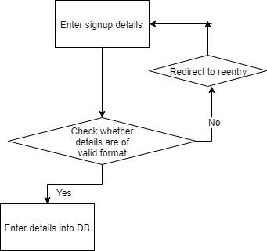

Figure 25 : Control flow graph for Signup feature

Cyclomatic complexity = No. of predicate nodes + 1

**CC = 2 + 1 = 3**

|  |  |  |  |  |  |
| --- | --- | --- | --- | --- | --- |
| **Test Case ID** | **Test Scenario** | **Test Data** | **Expected Output** | **Actual Output** | **Pass/Fail** |
| 1. | Enter details in field | Add blank in all fields | Please fill valid details | As expected | Pass |
| 2. | Enter details in field | Add wrong email address | Please fill valid email | As expected | Pass |
| 3. | Enter details in field | Add data of over permissible size | Please adhere to field size | As expected | Pass |

Table 14: Signup testing

## 8.2 | **Login feature**

Figure 26 : Control flow graph for Login feature  
  
Cyclomatic complexity = No. of predicate nodes + 1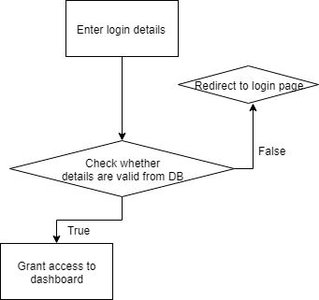

**CC = 2 + 1 = 3**

|  |  |  |  |  |  |
| --- | --- | --- | --- | --- | --- |
| **Test Case ID** | **Test Scenario** | **Test Data** | **Expected Output** | **Actual Output** | **Pass/Fail** |
| 1. | Enter details in login fields | Add blank in both fields | Please fill valid detail | As expected | Pass |
| 2. | Enter details in field | Add wrong email address or password | Please fill valid detail | As expected | Pass |

Table 15: Login testing

## 8.3 | **Adding an Internship**

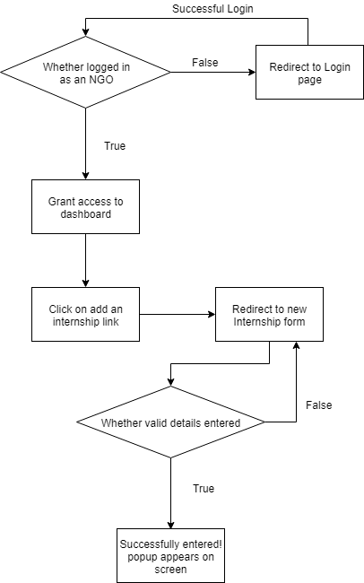

Figure 27: Control Flow Diagram for adding an internship

Cyclomatic complexity = No. of predicate nodes + 1

**CC = 2 + 1 = 3**

|  |  |  |  |  |  |
| --- | --- | --- | --- | --- | --- |
| **Test Case ID** | **Test Scenario** | **Test Data** | **Expected Output** | **Actual Output** | **Pass/Fail** |
| 1. | Enter details in form fields | Add blank in all fields | Please fill valid details | As expected | Pass |
| 2. | Enter details in field | Add data of over permissible size | Please adhere to field size | As expected | Pass |

Table 16: Adding an internship testing

## 8.4 | **Search for an Internship**

Cyclomatic complexity = No. of predicate nodes + 1

**CC = 2 + 1 = 3**

|  |  |  |  |  |  |
| --- | --- | --- | --- | --- | --- |
| **Test Case ID** | **Test Scenario** | **Test Data** | **Expected Output** | **Actual Output** | **Pass/Fail** |
| 1. | Enter details in form fields | Add blank in all fields | Please fill valid details | As expected | Pass |
| 2. | Enter details in field | Add data of over permissible size | Please adhere to field size | As expected | Pass |
| 3 | Not logged in as a student | Logged in as a company/NGO | Inactive apply now button | As expected | Pass |

Table 17: Search for an internship testing

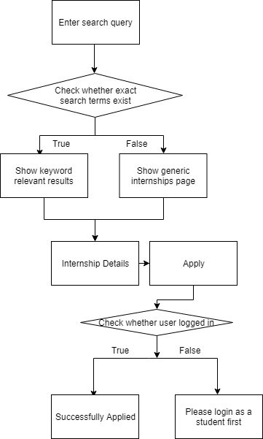

Figure 28: Control flow diagram for searching an internship

# 9 | Memos

**NGO::CONNECT**

**Memo**

**To:** Raghav Singh(coder)

**From:** Anushtha Kalia(Manager)

**Date:** 30-10-2018

**Re:** Foreign key issues in the database

**--------------------------------------------------------------------------------------------------------------**

I was going through the database and found some serious glitches in the foreign key which was given to the intern select id and the ngo id. Both these keys have to be specified in the other table as well. Kindly get it fixed as soon as possible.

**NGO::CONNECT**

**Memo**

**To:** Nikhil Maheshwari (Designer)

**From:** Anushtha Kalia (Manager)

**Date:** 15-10-2018

**Re:** Home page of the website

**--------------------------------------------------------------------------------------------------------------**

The front end part of the website is going really slow and we have to go-live in a some days, the homepage of the website does not seem attractive and also the carousels are not properly aligned. The website lacks significant information on the homepage about the portal. Try to fix it as soon as possible and revert to me as fast as you can.

# 10 | References

1. Software Engineering: A Look Back and A Path to the Future. Leveson, Nancy, December 14, 1996.
2. Applied Software Project Management, Andrew Stellman & Jennifer Greene, O`Reilly, 2005
3. http://www.bagyatech.com/waterfall-model/, November 10,2018
4. https://slideplayer.com/slide/7340672/, November 10,2018
5. https://www.fundsforngos.org/featured-articles/ngo-careers-job-ngo/, November 1,2018
6. https://www.youthkiawaaz.com/2017/05/9-things-to-know-before-joining-the-social-sector/, November 4,2018